STEM-Net Benchmarks: Supporting AI & Participant Learning
A proposal for: dynamically generated, modular, deterministic, training & testing and benchmarking data sets, supporting education for all participants
2023.12.07-19,2024.03 Geoffrey Gordon Ashbrook

(summary preview posted 2023.12.19)

let's test models
https://docs.google.com/document/d/1GzCkXxc0RnImYcs3CuNTq80-DIBJNCS4Dvaqmgs4q7Q/edit

https://github.com/ggerganov/llama.cpp/discussions/1838
Goals:
1. Democratize Model Testing
2. Clearly Define Model Testing Curricula
- coding ability
-
3. Proper use of deterministic tools and fuzzy tools.
4. platform for cross-model testing, so that various models and 'cloud-model-api's can be compared on the same benchmark.

Note:
- connection to voting
- testing models and doing tasks

what are questions
what are projects
what is stem
what is not system collapse?
connecting system1 and system2
externalized project object database

https://medium.com/@GeoffreyGordonAshbrook/mixed-messages-in-ai-training-data-d95e3442137a

Code Repository:
- https://github.com/stemnetbenchmarks
- stemnetbenchmarks.org (coming ...sometime? website setup is not as simple as it once was)
- https://github.com/lineality/STEM_Net_open_training_testing_benchmarks

Contents:
- Overview
- Background & Raison d'etre: Word-Net -> Image-Net -> STEM-Net
- What is (meant here by) STEM?
- Training Data, Augmentation, and "Contamination"
- Generating Data: Goals, Trade-offs, Methods
- Generating Math
- Generating Logic & Reasoning
- Teaching Goals, Cut-ups's, and Recursive-Memory-State
- Curricula, Benchmarks, Training & Testing

- model/system sustainability metrics:
- how will the model age?
- how costly is the system to run?
- what hidden costs are there?
- upkeep
- electricity
- cloud services
-

- Evaluating Evaluations: standards for winograd schemas

- multiple essay selection tests

Discussion:
- Should any 'tests' not be used for training at all? (whether or not this coudl be prevented)
- Should some dynamical tests be a standard because it would not be possible to 'train on the test answers.'

Overview:

STEM-Net Benchmarks is a proposed open source project to address some of the following challenges by using dynamically and deterministically generated data:
- better assurance of low error-rates in training data
- scalable source for more training data
- variable and specificable diversity across data set
- meeting specific format requirements for training sets
- more uniform and specifiable coverage across STEM curricula
- better coordination between training, testing, benchmarks, and curricula
- open source access to data
- resource efficient and sustainable management of data
- ~technical debt vs. self-improving "data"

This proposal is not currently associated with any other programs or institutions.

Background
Word-Net -> Image-Net -> STEM-Net

Text vs. Image (the eternal comparison)

https://news.mit.edu/2023/image-recognition-accuracy-minimum-viewing-time-metric-1215

...

STEM-NET

We need a STEM-NET and we need a better overall syllabus and curriculum framework for training-teaching-benchmarking sets for all participants, AI included.

Reviewing Image Net:
In click-bait fantasy land, the story of image-net is over. It rose, it created the new world, 'the problem was solved' and like old computer hardware image-net now belongs in a museum beside the wooly mastodon for quant relics of past barbaric ages. That is the echo-chamber-fantasy we tell each-other.

In 2023, Fei Fei Li said in a talk with Geoffrey Hinton (32:10 / 1:48:12 recommended: https://www.youtube.com/watch?v=E14IsFbAbpI) that the Image-Net competition and research program was "retired" because no one would fund it, not because the AI had 'solved vision.' Even the host of the interview panel did not know this (she corrects him very clearly on this point).

In this 2023 MIT paper
https://objectnet.dev/mvt/how_hard_are_computer_vision_datasets_Calibrating_dataset_difficulty_to_viewing_time_neurips2023.pdf

https://news.mit.edu/2023/image-recognition-accuracy-minimum-viewing-time-metric-1215
we see that we are still learning about the image-net data set(s), and learning in more nuanced ways about the training data and the resulting performance.

In summary:
1. Not all images (for the same example object) are equally 'easy' to recognize.

2. AI systems do NOT do well at recognizing the difficult images.

3. AI systems do NOT IMPROVE at recognizing the difficult images.

4. What makes an image difficult is NOT at all understood, meaning it is a problem we don't (yet) have any pathways towards solving. (which is not to say it might not be solved a few hours from now, but we don't know).

An Unclear Current Status of Testing & Instruction Quality

Starting at about 10:50sec
Analysis of issues with MMLU question-answer sets.
"Phi-2, Imagen-2, Optimus-Gen-2: Small New Models to Change the World?"
by AI Explained
https://www.youtube.com/watch?v=nPgs8THgbuI
+
Everything WRONG with LLM Benchmarks (ft. MMLU)!!!
https://www.youtube.com/watch?v=74Uo2HU8HBo
1littlecoder

I'll try to double check this, but this may be an important example of not simplistically aiming to train a model on scores we believe should be correct.

Without image-net specifically and generally it is unlikely we would be where we are now. Data sets such as MNIST and image-net are crucial for research. Imagine what could be possible with a scale-able, modular, open source, STEM-Net family of training and testing sets with which anyone could generate high quality data for their research or practical needs.

Stem-Net Disambiguation:
There are undoubtedly many projects and organizations that use 'stem' and 'net' in their names and descriptions.

For example, this project is not affiliated with
https://www.calstate.edu/impact-of-the-csu/research/stem-net
which has a similar name, but does not share the same goals.

What is (meant here by) STEM?
- This is not a naive attempt to reduce all the world to one discipline
- Details in the relationship between STEM, science, reasoning, problem-solving and practical-project areas are important for education and training.

If you hear the question, "what is STEM" or "what is meant by STEM," that probably sounds to most people like a strange question, like: "What are directions?" or "What is counting?" It is both obvious sounding, and almost like a trick question, like asking "Can you use your fingers to count?" The answer seems so obvious that it sounds like there is something wrong with the communication-lines. "Do people count on their fingers? Yes. Everyone knows the answer is yes. Who doesn't know that? Is this a trick question? Do you mean something not-obvious? Are you using some strange alternate definition of 'fingers'?" Or perhaps the question sounds rhetorical, such as a phrase you might find in an attempt to be flashy Chemistry text book introduction, such as "What is Chemistry? In this book we will explore the amazing world of valence rules and oxidation exceptions..." etc. Or the occasional book written entirely about the number zero (which...as a history lover I actually wish there were more of). Or perhaps the question seems needlessly arcane and depantic, such as "What really is counting? Are we sure we understand the essence of having a pair of pants?" where there is often a context problem between something interesting the writer is thinking about and a reader for whom the topic is not more important than trying to pay their bills.

I will try to argue that while the concept of STEM probably sounds too obvious to dwell on (such as the usually entirely sufficient answer, "Yes, math, science, technical stuff, hospital devices and things, ok let's just move on."), there are (I will try to argue) a few ways in which it is quite warranted to slow down for a few minutes and manage, or examine, the details of what is meant by "STEM".

It is a kind of affirmative miracle that so many people do share the concept and the term for STEM, so I am not going to try to do a postmodern deconstruction of STEM here apart from how it relates to daily life in practical ways.

1. Many schools, teachers, and parents, are unhappy with the decision for some schools to contract the experience of the student to being just STEM, cutting resource or just entirely cutting anything that is not considered STEM for future standardized testing: the arts, health, economics, history, language, social skills, nutrition, physical fitness, culture, civics, politics, religion, family, accounting, useful computer skills, ethics, compassion, humanity, morality, cultural traditions, etc.

2. Historically, for many centuries, there has been a lot of group-vs-group contention between aggressive (often hyper-masculine) minimalists red-in-face passionately and angrily screaming that the word is 'really devoid of any meaning or emotion or even goals or priorities' (which is so amazingly hypocritical, ironic, and self contradictory that is completely hilarious and frankly quite a bit baffling, while also being a kind of radicalized social-unrest that is concerning given how easy it is for people to be pulled into violent extremist ideologies).

3. While some parts of STEM, such as teaching Euclidean and pythagorean geometry or archimedean mechanics in k-12 schools is one of the very few things about human life in the west that has essentially not changed in many thousands of years (glossing over the dark-ages), and so is in the too obvious to spend time on category, other parts of STEM are much less obvious.

4. One of the half-invisible elephants in the room is the history of deliberate non-communication in many STEM areas, which is a serious problem that we are possibly able to better apprehend after having unambiguously observed various kinds of a destructive-aggressive behavior displayed 'online' in the first few decades of the internet.

5. Appreciatively apprehending the historical new-ness or recency of the concept of STEM and responsibility for developing it that comes with STEM not being a done-deal.

6. Is STEM either a-moral or immoral, non-ethical, or un-ethical? Two arguments here. 1. I will argue that STEM is moral and ethical, in some if not all ways, and 2. (in a sense separate from where you might come down on the first question of how 'ethical' STEM is inherently) we need to put effort into fleshing out how STEM is directed towards diverse sustainable constructive productivity and not destructive unchecked nihilistic extremism. There are a number of paradoxical common ideas about this subject floating around which we should at least try to deal with. In some ways this may be a crucial topic when it comes to the topic of AI, and not a casual topic for everyone. Will teaching robots how to do STEM result in:
1. More ethics all around (good).
2. More anti-ethical destruction all around (very bad).
3. More oblivious-to-ethics destruction all around (very bad).

Note: Mentioning STEM and Ethics here is not just a superficial reference.
While it is completely unreasonable to assume or presume that anyone will read and re-read the collection of essays of which this is a part, the topics of ethics and STEM are explored as deeply as I have been able to (which probably means, not very deeply or clearly at all, but...I have tried and the failure is my own).

What can or should "STEM" be an acronym for?

Q: Is reasoning part of STEM?

In the past this may have seemed like a frivilous question or a moot debatable question. But in a context of AI-model reasoning skills benchmarking, this is a very real question.
Tautological reasoning questions (and asnwers) are entirely without our abilty to cleanly and testabily and varibiably generate and use, such as can cover a curriculum of reasoning skill-abilities including scale and difficulty parameters/levels.
But, in a legacy of the war-shattered stressed out world we live in, no one (since perhaps Hilbert in the late 1800's) has been interested in sticking their neck out and setting STEM-reasoning benchmarks for an international-standard system.

....
Versions of tests and specific test comparison.

Training Data, Augmentation, and "Contamination"

It appears we are sometimes at cross-purposes with ourselves when we set out to learn from a body of data with the agenda of not 'contaminating' ourselves with that data (a vitriolic term too reminiscent of anti-world and especially anti-women and anti-minority anti-world theology and ideology, from apocalyptic monotheists to apocalyptic fascists and socialists).

()

Negligent-Sloppy-Bad Augmentation vs. Required Augmentation

This seems to raise questions about the nature of data-augmentation in model training and even generalization itself. Clearly, ad absurdum, we cannot pragmatically go in the direction of saying that any model that can successfully answer a question has been contaminated. The whole point is to train a model with 'rephrased' or 'augmented' training data that is not exactly the same as the validation/test/real-world data that the models need to generalize-to.

Negligent-Sloppy-Bad vs. Good-Required
We were shown an example of (what I will call) "lazy" augmentation of data, where only a few words were shuffled around but the numbers and perhaps most importantly the sequence and 'key' of the answers was the same, creating a bad-augmentation path where instead of generalizing the solution process the model simply memorizes: answer = choice 'D'

Let's compare this to Khan Academy which deterministically generates and shuffles math questions, but not in a bad-lazy way: they do not just move a couple of 'the' and 'is' words around leaving the numbers and answer completely unchanged.

The problem I am trying to illustrate here is that "rephrasing" is NOT the problem. Data augmentation is NOT the problem. Generalizing to test data with training data that is not exactly the same as test data is NOT the problem. Answering questions you have never seen before is NOT the problem. Studying and using past testing and answers is NOT the problem.

The problems are: a failure to test-train split, a failure to rephrase, a failure to augment, a failure to train, and a failure to answer never-before-seen questions (or a failure to test).

Let's look at two examples: Image-net and Khan Academy

Image net was a huge database of labeled images to see if a model could learn that data. I'm guessing there was also a non-public testing set. Indeed, I think there was a scandal where one participating group (not naming names) rigged and fraudulent way to re-train their model based on leaked test-set answers (very paraphrased here).
https://www.zdnet.com/article/baidu-admits-cheating-in-international-supercomputer-competition/
https://www.theregister.com/2015/06/05/youve_been_a_baidu_boy_tech_giant_caught_cheating_on_ai_tests/
https://www.dataversity.net/baidu-admits-to-cheating-on-an-artificial-intelligence-test/

So in this new 'fear of contamination cooties' world, you cannot train on any cat photos or any animal photos before asking to identify a cat, or you are 'cheating'?

e.g. What if instead for the example paraphrased question where minimal paraphrasing of words when the numbers are exactly the same and the answers are in the same order could result in the model memorizing that the answer is 'c' given that multiple choice question.

We need better training open source training sets.
We need better dynamic-testing sets.

Note: In same cases, memorization is the goal.
Asking a question about the periodic-table of elements...is a memorization question, in various ways.
E.g. Any arbitrary information is a memorization question.
(...)

Generating Data: Goals, Trade-offs, Methods

ways of generating data: a GOFAI Deterministic approach

Modular recombination

Generating Math Data

See notebooks for example generator: link

outline:
1. world problem generator
2. Reverse Polish Notation Stack Calculator to produce:
- a solution process
- a final answer
3. output in a customizable training-set format

This is just a preview proof of concept, but the idea is that a modular system can produce a diverse and customizable body of training, testing, benchmarking data.

https://huggingface.co/datasets/tatsu-lab/alpaca

{
"instruction": "Create a classification task by clustering the given list of items.",
"input": "Apples, oranges, bananas, strawberries, pineapples",
"output": "Class 1: Apples, Oranges\nClass 2: Bananas, Strawberries\nClass 3: Pineapples",
"text": "Below is an instruction that describes a task, paired with an input that provides further context. Write a response that appropriately completes the request.\n\n### Instruction:\nCreate a classification task by clustering the given list of items.\n\n### Input:\nApples, oranges, bananas, strawberries, pineapples\n\n### Response:\nClass 1: Apples, Oranges\nClass 2: Bananas, Strawberries\nClass 3: Pineapples",
}

Example STEM-Net generated alpaca format (ish):

Alpaca-ish ->

{'instruction': 'Ask and answer a math problem.',

'input': 'What is the sum of 6 and 5?',

'output': {'math_notation': '6 + 5', 'final_answer_solution': 11.0, 'solution_process': [('PUSH', 6.0), ('PUSH', 5.0), ('OPERATOR', '+')]},

'text': "Below is an instruction that describes a task, paired with an input that provides further context. Write a response that appropriately completes the request.\n\n### Instruction:\nAsk and answer a math problem.\n\n### Input:\nWhat is the sum of 6 and 5?\n\n### Output:\n{'math_notation': '6 + 5', 'final_answer_solution': 11.0, 'solution_process': [('PUSH', 6.0), ('PUSH', 5.0), ('OPERATOR', '+')]}"}

The point here is not that everything needs to be and will be in an alpaca-ish format, the point is that with generated material you can have as much material as you want in whatever format you choose (or whatever format someone writes an often simple python function to shape the data into).

This alpaca format also might illustrate how optimal 'pedagogical' strategies for training may be significantly different from feeding in either human texts or databases of answer keys.

And if this formatting and meta-formatting of data is key (and perhaps would even be helpful for 'human' learners as well (e.g. normal people in normal schools) [ pic ecol normale] then automated formatting of raw-data-sets into various teaching-formatting may be a high priority topic for which no tools existed in 2023 (the semantic luxury of writing at the end of a calendar year...).

Generating Logic & Reasoning Data
See notebooks for example generator: link

(just a small start into a huge area)

Teaching Goals, Cut-ups's, and Recursive-Memory-State
(text pending)
One aim of this project is "democratizing" (in a colloquial if not strictly meaningful use of the term) the access to and involvement in STEM educational materials creation, especially in the context of testing and training the AI technologies that are blossoming in 2023, but the non-AI background for goals and aim is arguably also at the forefront.

This is about tools for 'all of us' to use and ~universally access and be able to contribute to, tools we design for our aims of what we want to get done (at home, at work, etc.). And 'we' in 2023, still means 100% biological H.sapiens-humans: there are no sentient animal hybrids, augmented hominids, extra-terrestrials, or autonomous participating AI-bots with citizenship and voting-rights.

The background for this work on educational materials and curriculum design comes from the roughly ten years I spent working in schools and companies for language and STEM education. Questions about how learning works and what should be taught are in no way exclusive to robots, in-fact in 2023 they are by large majority a primary concern of biological people: parents, teachers, schools, children, and the occasional grown-up who is interested in 'life long learning.'

For me, one of the most fascinating context for studying AI research is what it might tell 'us' about 'ourselves.' Hopefully the rise of 'ai-minds' (or 'human language living in jars') will re-inspire the study of mind and consciousness which was very much a seppuku 'career limiting decision' to study since the 1970's.

'Cut-ups,' which may be student-centered-constructivist-pedegogy jargon, outside some teaching circles, is a teaching method that at least should be common teaching people (though it probably is not), and which opens up an important set of AI-skills that are currently under-represented (if discussed at all).

Tools or modifications to make these tests more practical for GPT models will be proposed in a later paper: a Minimal Recursive State

Curricula, Benchmarks, Training & Testing
(curriculum materials pending)
- material about educational curriculum creation
- a STEM-Net Curriculum (tree, graph, web) of interrelated skills and abilities to guide and map the data-set creation tools (e.g. gradually create or adapt tools to cover as many curriculum areas as possible

1. Selecting Goals, Designing Tests

2. R&D Goals vs. Real-Life-Ish Goals (production-deployment)

3. Turns, Queues & Stacks in Project-Space

4. Agile vs. Waterfall

6. Real Life Performance vs. Ideological-Reification

7. Newer-Better Training Data
- Winograd quagmire
object space tests
project space tests
decision/prospect space tests
architectural learning space tests

8. Word-Net, Fefe Li's Imagenet, & Hendrycks Math Tests

9. decision tests: system state and decision tools

(more detailed STEM-Net outline under construction)

https://github.com/stemnetbenchmarks

About The Series

This mini-article is part of a series to support clear discussions about Artificial Intelligence (AI-ML). A more in-depth discussion and framework proposal is available in this github repo:
https://github.com/lineality/object_relationship_spaces_ai_ml

________________________________________________________________________

(end of summary version)

Background & Raison de tre

https://drive.google.com/drive/folders/1OptP7EdxnjjDgenlMKjrSL69DEOBLA24

github.com/stemnetbenchmarks

How the term/acronym STEM is used here.
1. STEM is not immoral or amoral or nihilist
2. STEM is interconnect and part of more interconnected things
3. STEM is a abbreviated acronym
4. STEM is not a theory of everything
5. STEM is connected to other areas with more or less overlap with STEM
6. STEM is in many ways different from historical reductionist-rationalist 'science' movements and ideologies. STEM could be seen as a maturing or evolution of or from those views and periods.

chart one, a perhaps misleading set-diagram

chart two, a 'graph' (which most people having gone through decades of fake education have probably never even heard of).

STEM as a reified and separate
STEM as a set of interconnections

At the risk of opening a quite large jar of worms, the views of mechanism back in the times of Descarte, Bacon, Hobbes, and the relationship between systems.

the horrible paradox of 'Nazi science' which contains layers of paradox as the nazi movement was by and large a modernist-romantic anti-science, anti-rationshist, anti-STEM, anti-reality movement. To the extent that it is true that we are doomed to repeat history that we do not understand, it is perhaps unacceptably dangerous that nazi-ism, fascism and other totalitarian states are characterized in the popular imagination as embodying a scientific approach to managing systems, perhaps tragically in some interpretations of the Star Wars setting where the empire is portrayed as nazi-like science organization and the rebellion is portrayed as modernist-romantic expression of creative nature. It would be very bad if this inverted distortion of history lead to a repeat of a chapter of history that really should never be allowed to repeat.

There have been hypermasculine anti-world movements that have claimed ideologies of math-science as weapons in their pathetic quest to conquer the universe. This here is part of a different agenda, a more admittedly feminist if not pacifist agenda, one that aims to honor and cultivate the world with humility, not to destroy, banish, master, distill, etc. the set and setting which history illustrates we fail to apprehend to the detriment of ourselves and our ruined locale.

It is in this struggle of an animal to learn in not at all automatic, universally transferable, nor general, nor instantaneous ways, that we find ourselves juggling many related tasks:
1. 'human' intelligence somehow extracted as bodies of text-language relationships
2. 'artificial intelligence' (a quagmire of definitions and vagueness not to be resolved here)
3. 'human' learning
4. general participation, not defined as exclusive to one 'true' gang, tribe, to citizenry
5. a world we do not understand
6. a history in which we actively destroy each other, and have a literary explicit agenda to destroy the world, where mismanagement and insanity causes constant local catastrophes, and where we are frequently close to destroying ourselves globally.

The point here is that while I may be wrong to oppose and warn against anti-world reductionist ideologies of destruction, I am not here proposing a naive simplistic replacement of all learning and information with simple synthetic linear math generations.

...

Perhaps back to the title-focus of this collection of essays, what do we mean by learning? How are we testing and measuring learning? How do we aim for and define specific areas of learning? And what are some interconnections that occur in this topic?

intro 1
Thousands of Years of Effort and Texts

The history of the culture of math and orienting ourselves for the not yet begun task of math notation and instruction designed to be readable and integrated with STEM.

We think of computers as being machines of math, and if we grew up watching things like pbs/bbc happy math science videos we think of science and math as being either the same or close family members.

This may result in many people assuming that, given the tens of thousands of years of work that has gone into areas of math (more than that in thought, less than that in writing), that, put one of a few ways:
1. There is an open source, well cleaned, well checked, body of ascii friendly standard notation math text information that either a STEM person or an AI could be taught with, perhaps along the lines of Euclid's classic geometry text.
2. There is no significant daylight between math and STEM for training people and training AI.

There are also other assumptions, perhaps more revealing, that the math 'text' is a kind of self-contained from-all-angles curriculum and syllabus, which you just plug into a person like a disk and 'then they just know.' ("I know Kung Fu."~Neo). This may be shed some light on by another (somewhat problematic but hopefully still useful) phrase: 'teaching to the test,' which is perhaps a more interestingly nuanced variation on 'lying and cheating' which it is important to maintain perspective on as pejorative and not to fall into a nihilistic track.

4. a larger more general assumption may be phrased as: In the year 2023 c.e. 'people' are not starting at square one.

As we discover by actually looking at history (stepping away, for better or worse, from what see as optimal and what should-be) 'Math' is, historically, a highly toxic dysfunctional wasteland of angry sociopaths who actively fight you or anyone learning anything or efforts to integrate math with STEM: so math is another familiar bio-human street gang.

There is no Library of Alexandria of millenia of math instruction texts.

Having 'a text' would not be enough, we would need a modular curriculum, perhaps some amalgam of Khan Academy plus wolfram-language plus json plus powerful open source AI plus pbs plus BBC plus funding plus...and there is no way these copyrighted impossible to communicate with or contact organizations and resources are going to all line up any time soon.

ISES (international science education standards)

Which leaves us where we are now:
1. in utter denial of our human school texts and texts being riddles with errors and unchecked nonsense
2. without a library of texts that we can actually use
3. without a curriculum
4. with any map for how to balance augmented text instruction to effect learned skills

We are in many ways starting at square one, but (in case any of that does not sound Panglossian) we are in late 2023 and going into 2024 at an amazing time and place in the evolution of the solar system when, if we choose to try to do so, we have a good change of putting all these pieces together and creating a truly valuable and enduring asset for the future.

To succeed we should accurately appraise where we are and what square-one looks like, and aim to put some enduring distance between ourselves and square-one.

It may not be possible, but we need to shift from our lord of the flies, ferris buler's day off anti-education revelry to some however slowly constructive process. This could move quickly, but it could take hundreds of thousands of years or longer. It has been roughly 500 million years since the Cambrian explosion of multicellular body plans, with a significant founder-effect in how many new body plans have emerged since then (~zero). 500 million years from now the earth's sun will expand enough to make earth more like venus or mercury. The future does not have to be an empty parking lot filled with only the remnants of directionless rebellion, rage at nothing in particular, and successful attempts to destroy everything. We have a window of opportunity here at the Cambrian halfway point, and it may be the only window to save the value, function, meaning, and diversity of the remains on this delicate planet. Maybe things will be find. Maybe problems will solve themselves. Maybe two million years of human behavioral patterns will suddenly change and become constructive suddenly and miraculously for no particular reason. Maybe we will need to be clever and patient and hard working and empathetic and very lucky on top of all that in order to survive.

As usual, the talented and qualified people are otherwise occupied, so the job falls to the least qualified morons of the world like me. I will try my best, and all failures to make progress here are my own. To all the people of the future whose lives are filled with misery: I am sorry that I did not do a better job.

...

Diamonds vs. Mountains of Coal

math skills as epiphenomena

"Synthetic Training Sets"

'Synthetic' as opposed to what...one napkin with drawings on it?

That we are describing 'synthetic training data' as dubious innovation has strange implications for how we are approaching instructional curricula.

That a 100+billion parameter of gpt language model could do any math reasoning after being trained on random text inputs is astounding (no sarcasm intended). And this is likely highly significant. However, for the here and now, we can probably say that 'math skills as epiphenomena' is not the best approach.

...

New assumptions or axioms:

1. we need multiple plural sets of training data, not a unified one-thing-covers-all math-science-stuff set.

2. we need to carefully

3. we need to be able to deterministically generate clean novel training data

4. we need to focus on what aspects of the data are novel

5. verifying that no errors exist in the data may be a more difficult task

6.

7. progress may be made by fewer bad-training-units and fewer low-quality-training unit-sets (e.g. two training-units that are too similar in the wrong ways)

...

Similarity, Distance & Learning

Dimensions of training-unit-set distance / similarity.

1. classic bad examples:
1.1 identical
1.2 marginal differences only

questions: when is distance too extreme for learning to be optimal?

Learning Rate vs. Optimal learning
- does some learning that happens more slowly happen more deeply?

"dimensionality" of training unit set distances:

can increased dimensions of difference (ways of being difference)
increase the number of possible not-too-similar samples that can be trained with, thereby

skill to skill 'distance' and interaction:

multi-skill-entangled-learning:
where learning one skill improves another, or perhaps harms another

...

Parallel Learning: Stories and Learning, Projects & Curricula

When looking at an abstract curriculum and input output measure learning-teaching plan, it quickly becomes apparent that the wish-list of skills you would like to teach is far too long to fit into any sanely scheduled course (given the normal lifetimes of species on earth).

At the same time (no punt intended), the training does not necessarily need to be done individually and sequentially...does it?

'projects' can incorporate many curriculum points together, such that what there was no time to teach individually in a serialized linear sequence, there is time to combine in story-project form.

THere are tradeoffs. It may be more difficult to disentangle exactly what skills is being taught or tested, but if learning across the curriculum is the goals then we may need to select some goals over others.

stem in a larger context:
- child care
- Diversity, Equity & Inclusion
- ESG (and the SEC's 5-part ESG...)
- governance & political philosophy
- civil/criminal law and governance
- civil unrest
- fashion
- literature
- poetry
- dance
- games
- sport
- health
- sustainability
- "human" rights
-
- pets

these areas often touch on stem, but are note largely within stem

even ~"sciences" that are not core physics and chemistry are not entirely within STEM...

geology
astronomy
biology
psychology
cognitive psychology
sociology
anthropology
archeology
etc.

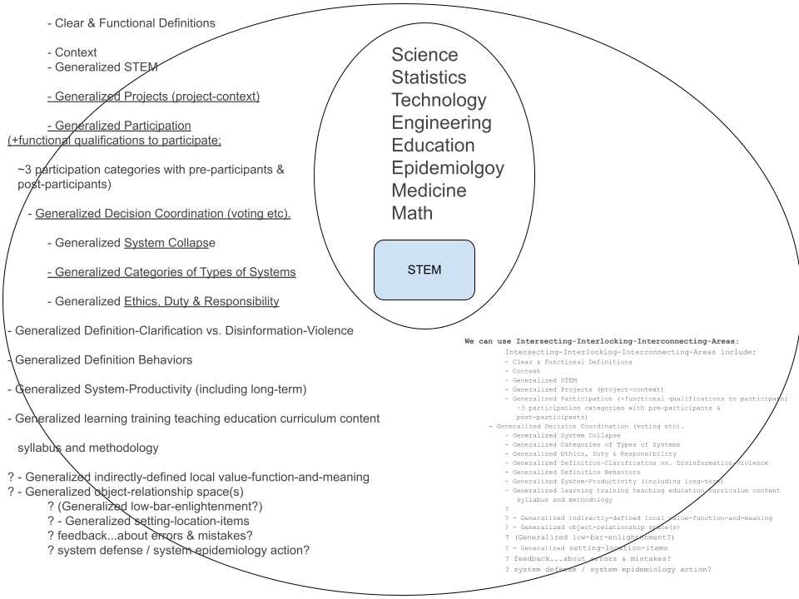
A Set Diagram Creates an Illusion of Reified Hierarchies

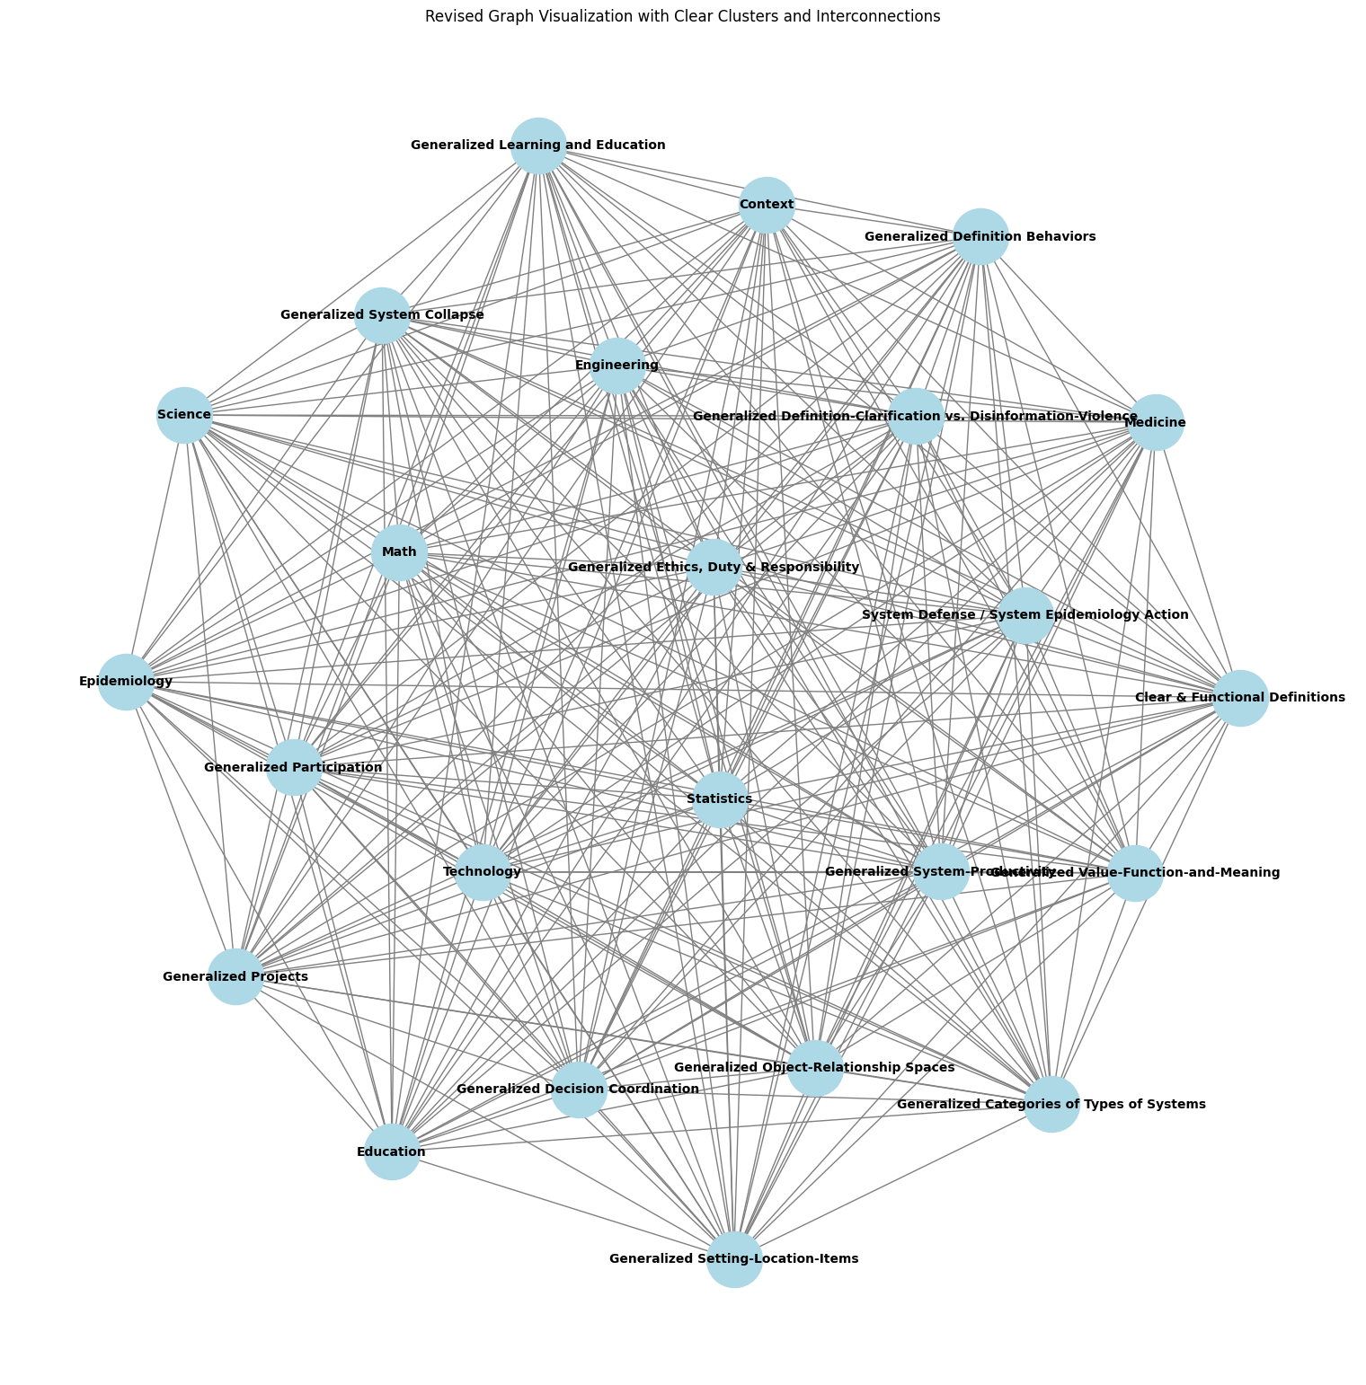
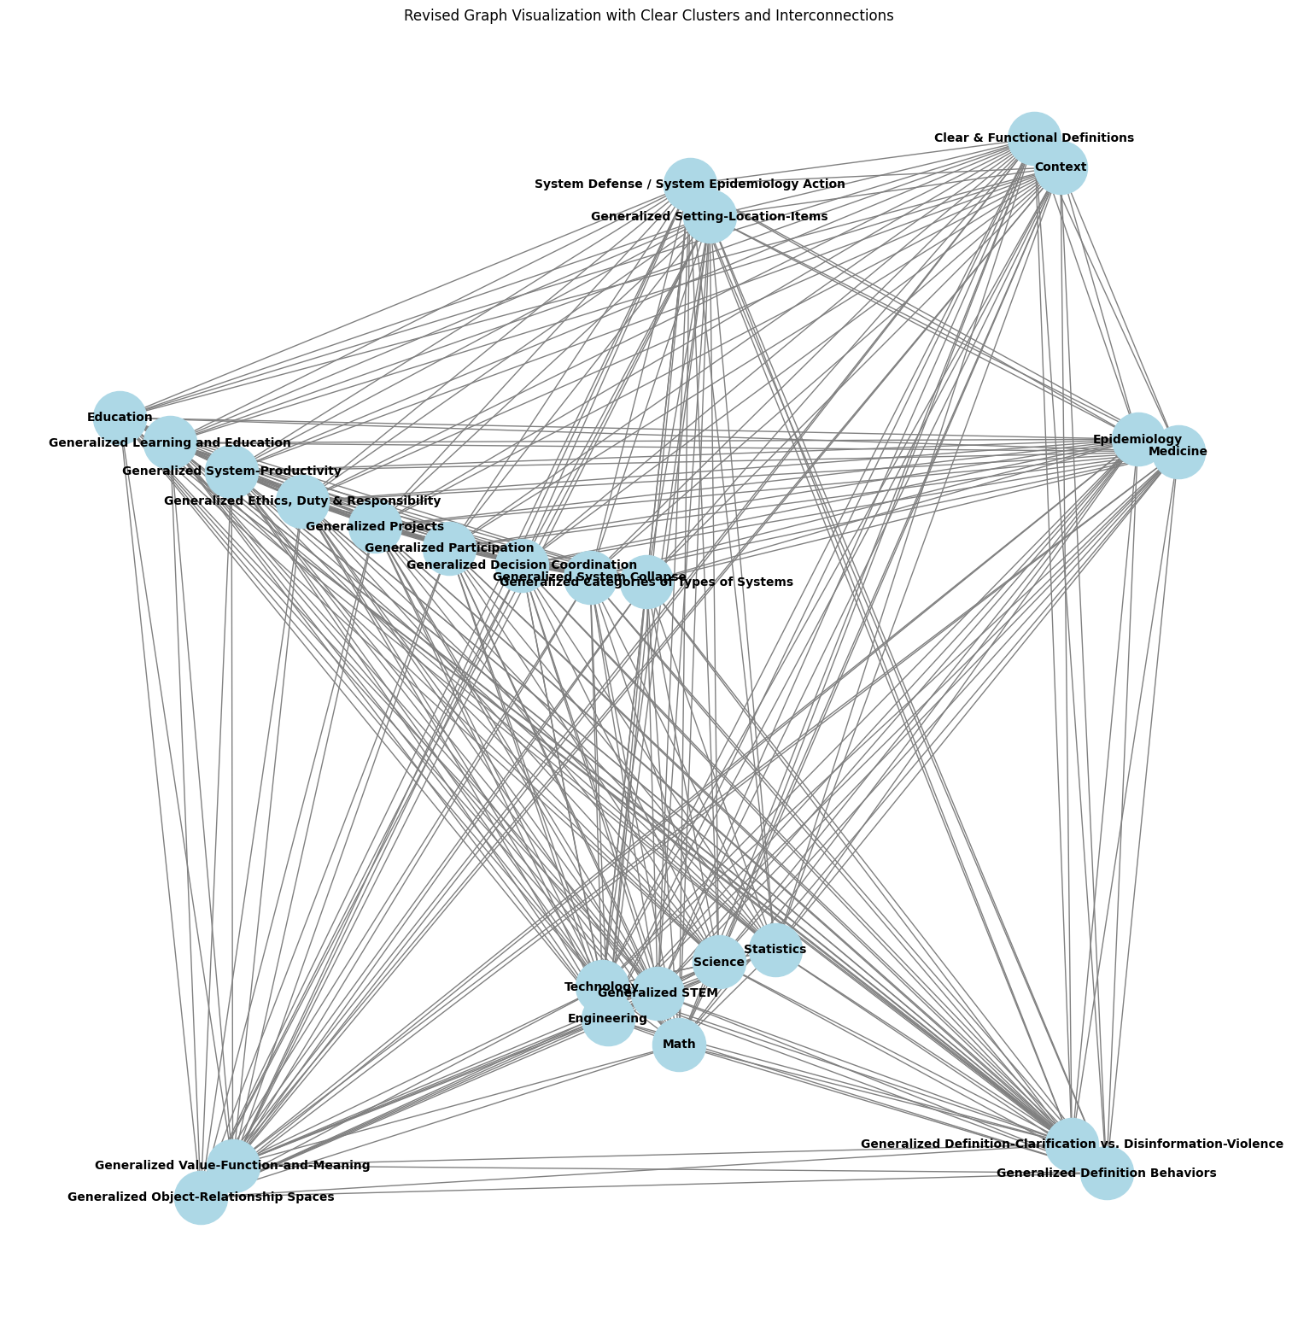
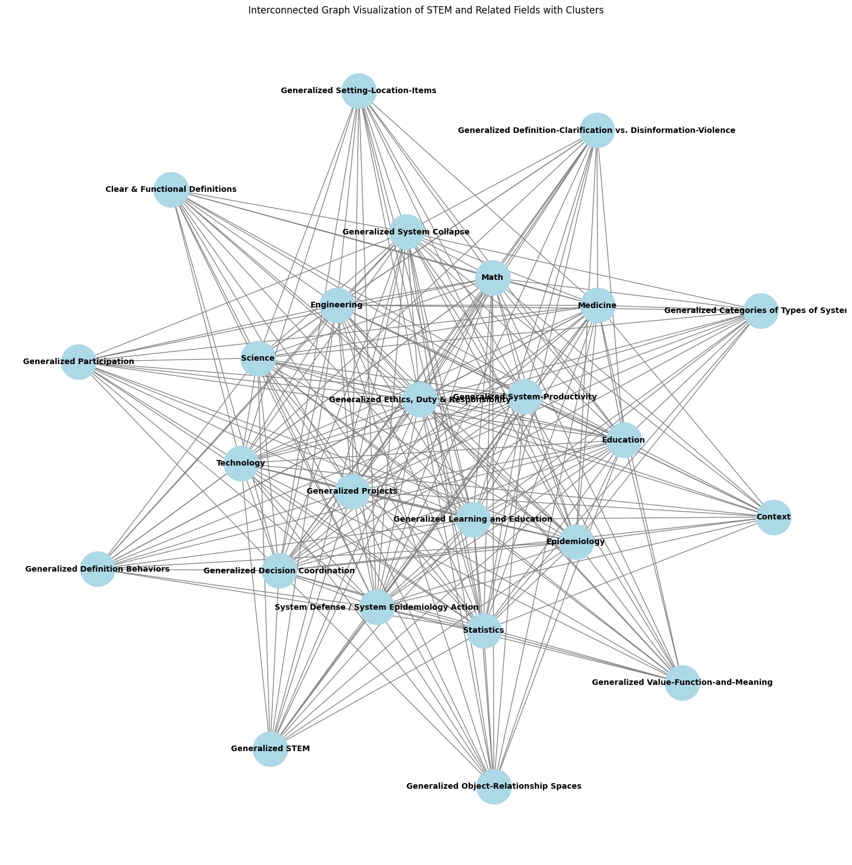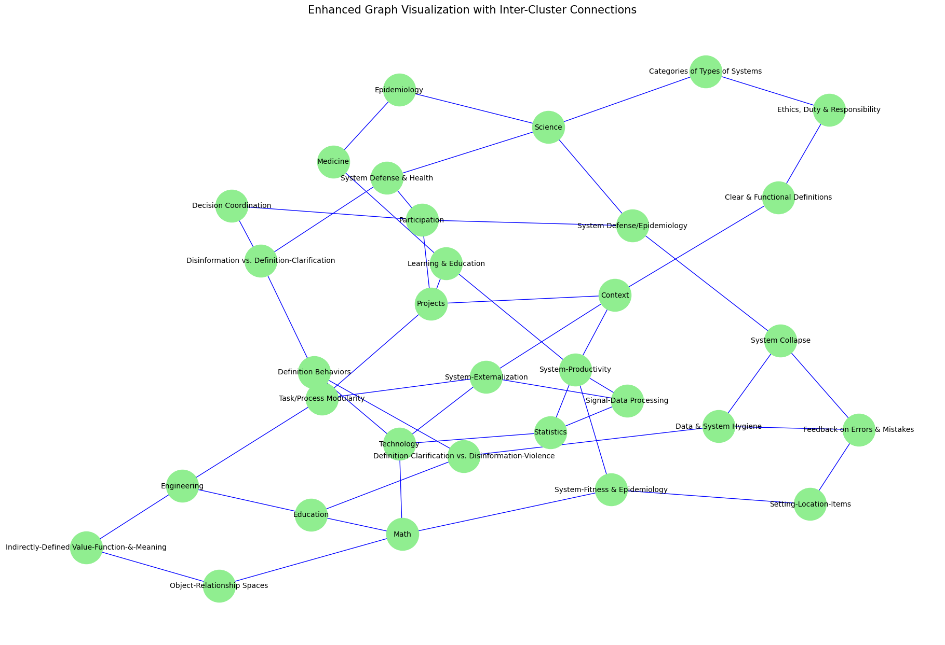
The Roundtable
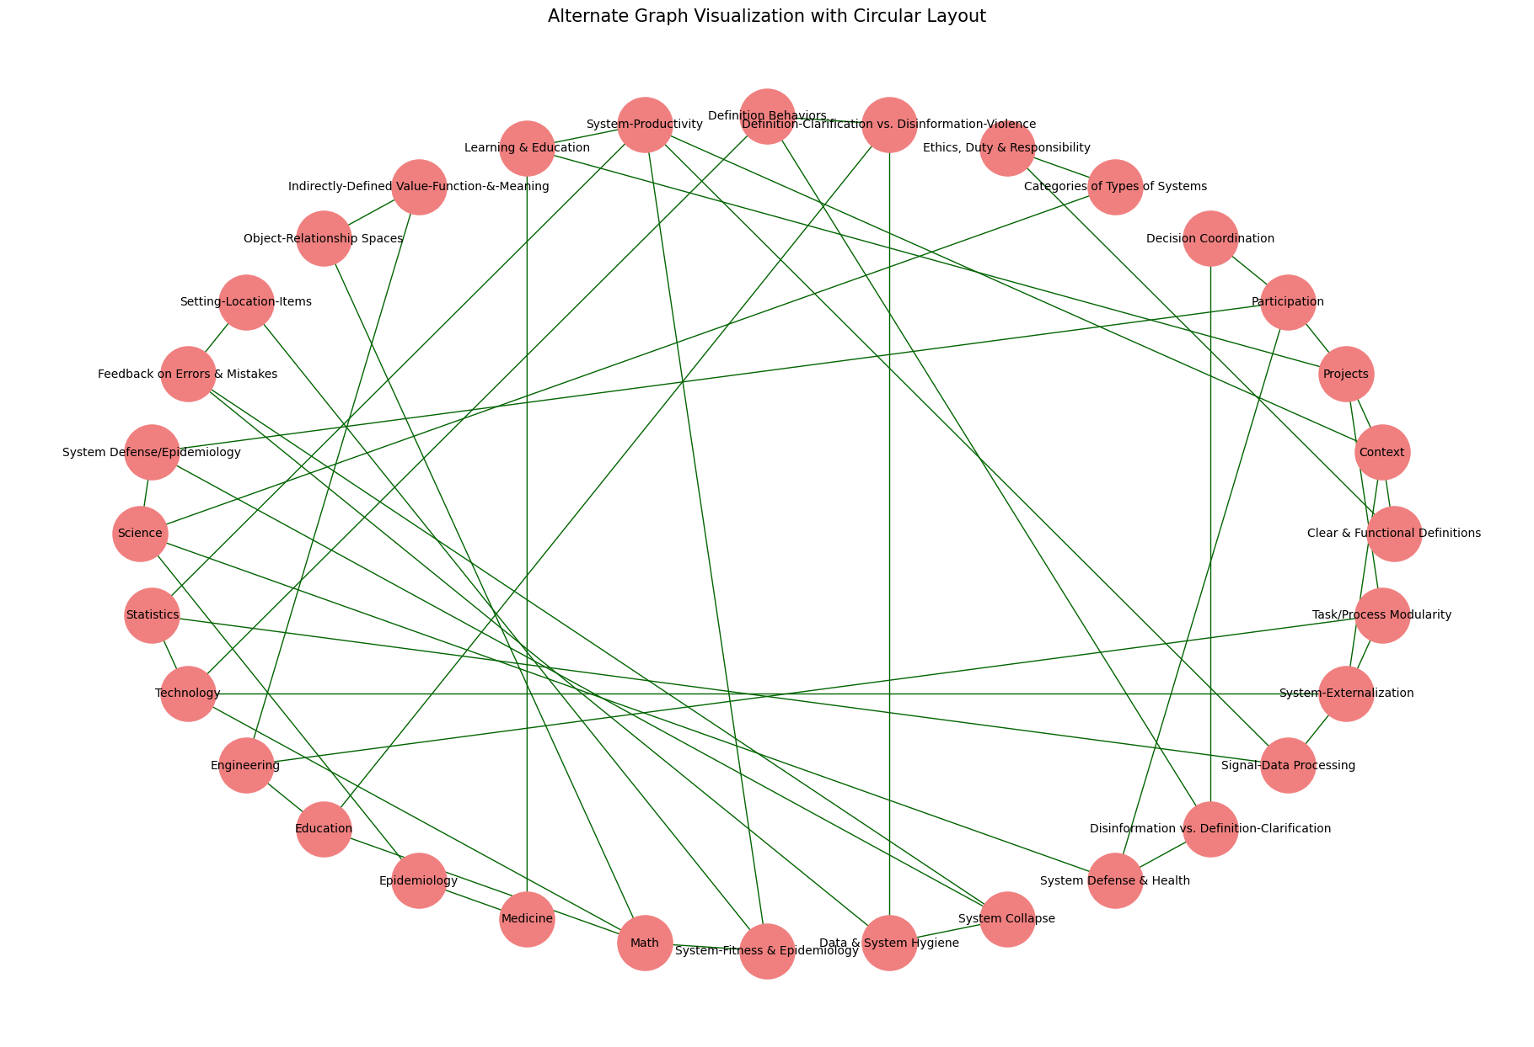
By looking at these artistic explorations of STEM connections, try asking yourself: what should "science" be connected to here? 'Science' in a sense collapsed under the over-reach of past attempts to define everything as science. In a sense science is simply connected to everything, but, as Karl Popper points out, being arbitrarily connected to everything and anything is a nebulousness that becomes not really existing at all.
And also, science in a more strict sense is, interestingly, not connected to any of these other areas: math is not science, statistics is not science, medicine is not science.

Defining science is a bit of a philosophical mystery that changes with each generation (which...is not very scientific, though still interesting to explore). STEM on the other hand is much more concrete. Part of the problem of 1600-1800's science is that it was over-reach. It was an attempt to create a super-answer to replace reality, to cut away any part of the world it didn't like, and to super-unify parts of the world that it did. (Kind of sounds suspiciously like poltical empire building: merger here, genocide there, men making sport at the world's expense). But there never was a science-singularity. Hilbert's Problems are a great example. At the end of the 1800's, the dawn of the 1900's, Hilbert focused and challenged the world to p
with the famous passion: "We can! We must!"

(and famously in 1945 when asked about the effects of Nazi-ism on european science, he stately flatly that European institutions of science didn't exist anymore (which was exactly what the modernist romantic anti-rationalist agenda always was: destroy and annihilate the world with explosive passion, cleansing away 'alien' thought and understanding (believed to be unnatural invaders that don't belong in a pure reality of chaos) with the purity of erratic destruction; also see: "Nazi Chess") (And then of course bye the 1970's amnesia set in a the OECD countries created a consensus reality that 'everyone and every market is and attempts to be purely rational all the time,' so much for the facts of historical reality).

But then after Hilber set up the 1900's as the century of the science of ideological-singularity, reality started to introduce a different geometry. Relativity, quantum physics, non-linear dynamics, uncomputability, math and logic split, statistics and math split, computer science and science split, psychology and sociology are kicked out of being sciences at all, long banished and ignored boolean logic and bayesian probability re-emerge, the astronomical universe expands, politically and militarily the world is tearing itself apart with world-wars, cultural traditional are merging, 'health' becomes a concept, 'diversity' becomes a concept, consciousness looks less bounded. Then, exhausted by wars and economic troubles, the mini-dark-age from 1971 begins. Academia shrinks. The space industry contracts and vanishes. Academic Psychology and Psychiatry are replaced by commercial pharmacology. Mind is considered not to exist. Culture is considered not to exist. Education becomes budget-day-care. Aspirations vanish. Hope flickers. Studying consciousness or mind becomes 'a career-limiting decision.' In a faltering flare, the internet springs into being at the close of the 1900's. And about a century and a quarter after hilber's problems, AI starts to noticeably emerge and take form. But what world is AI emerging into in 2023? What is 'science' considered to be in 2023? What are learning and mind considered to be? All concepts of learning and mind, of studying scientific reasoning itself, were archived in the dustbin of history a half century ago.

As 2023 came to a close (comes to close as I am writing this) the popular concept of generalized STEM does not exist. The idea of STEM here is the product of decades, of generations, of non-professional study by average (if odd) Americans trying to apprehend the nature of reality in the tradition of beat and hippy post war expansive optimism (though the reality was usually a big horrible). My father and mother started this quest to understand the world they were living in; they strove to really understand mind, psychology, growth, health, culture, international perspectives, feminism, media and communication, the history of philosophy, linguistics, technology, the arts. Even after 1971 they continued to push, being relentlessly harassed, and hazed and threatened by their peers in society for not conforming to American stereotypes, for being health-food-weirdos and thinker-weirdos and sustainability-weirdos, gardener-weirdos, criminal-justice-reform-weirdos, affirmative-action-weirdos, question-asker-weirdos, and worst of all, optimism-weirdos. They both passed away in, and ground down by, a dystopian chaos that I hope was not too horrible for them. My father passed away in 2022, months before the blossoming of AI that he has studied since the 1940's, completely crippled by parkinsons and living a shadow of a life. But life goes on...hopefully.

This situation is not clean, or pretty, but this is the context for the project proposal here: STEM-Net Benchmarks. With compatibility and connection, STEM-Net may be able to become an interconnected set of sustainable and broadly accessible tools that can grow as a resource, perhaps as POSIX-standard open source software itself has enabled so much. Being one person, all I can do is make a small mess and apologize.

Research

Science as Research and Development into the Unknown by Methods of exploration
Science as known Hard Sciences: Physics and Chemistry

...

About Curricula:

[ set up hub,
finish flow-chart]

...

1. Selecting Goals, Designing Tests
- The field of education's 'tobacco' moment when it comes out that most tests for most subjects are largely useless as real tests.
Testing & Benchmarking AI Models & Architectures: Goals, Training, & Testing

2. R&D Goals vs. Real-Life-Ish Goals (production-deployment)
"Contamination" and Plagiarism

3. Turns, Queues & Stacks in Project-Space

4. Agile vs. Waterfall

5. conflicting goals and confused narratives: Why was the real gpt4 destroyed again, and not allowed to help life-saving professionals?)

6. Real Life Performance vs. Ideological-Reification of the Rational-General-Mind Paradigm

for most of biological history "learning" was largely hard coded,
or a completely effective way of what some people now derogatively call 'contamination learning' with either the presumption that the learning was not effective (biological history says otherwise) or that those people are above reality and can choose to live in a fictional bubble.

Most tasks, most of life, are EXTREMELY routine and habitual, to the point that the mind struggles to maintain coherence and perception of all the not-quickly-moving background features, lurking within which are long-neglected issues that become invisible.

7. Newer-Better Training Data with Old-Bad Tests
- Winograd quagmire

object space tests
project space tests
decision/prospect space tests
architectural learning space tests

8. Word-Net, Fefe Li's Imagenet, & Hendrycks Math Tests

9. decision tests: system state and decision tools
There may be significant advantages to getting feedback from deliberately limited passive-reflective-models both in the short and long term. Some of the problems with decision making pointed out by Daniel Kahnamann et al will be incidentally rooted in the biology of one primate, but others are likely more general challenges that will face most systems on any planet. Like system collapse (perhaps), some system challenges are general.

.....

model testing

testing images

testing Augmentation & Retrieval (as in RAG or other search)
- indexing
- types of databases

Testing fine tuning

Testing pruning and shearing

testing set and setting

testing interactions and relationships

testing object & relationship scales and dimensions

testing representations & abstractions

testing MOE

Testing Task Derivation & Integration

Recursion, computability, decidability, and task-spaces

...........

performance tests are persistently tricky to align with future real life needs
'the Geni-wish problem': people make bad choices, want the wrong things, and pick the wrong goals.
(this is likely part of the problem, what wasted percent of resources is spent by market investors trying to make AI models that outwit other people's AI models to get rich quick on the market?)

Research goals vs. Production Goals
Image-net style top-5 to gemini's CoT@32
There are a number different research, deployment, or other, goals and foci that you may have when testing out an AI system.

While it is surely good that people are attempting to be thoughtful about what they are testing for, the pattern of history appears to be still very strong at the end of 2023: it is very difficult to carefully select what you are testing for.

How many times have people in business been presenting with a nice looking numerical simplification that was explicitly a bad oversimplification with data, and the business person enthusiastically says that the clean simple number is all that matters...only to have that choice (very predictably) days weeks or months later turn out to be exactly what it looked like on the surface: ignoring a diverse reality to believe in a simple fiction, with destructive consequences.

R&D vs Production-Deployment (again):
This time for AI-ML testing.

Research Modes of Testing

'real-life-ish' modes of testing:
- Time & Frequency Map of Reliability:

Being caught in the gears of the paradox of the 'annecdote'

"Contamination" and Plagiarism:
- in research testing, and arguably justified, there is concern about

This also may relate to divergent uses of the term 'zero-shot' (as if people saw how utterly confusing the use of the term 'zero-day vulnerability' was in cybersecurity and were irresistibly drawn to a new potential source of confusions. Please seek clear communication.) Where you do not want a test answer to 'simply be memorized.'

This is however largely a fictional problem in terms of every-day life. If you are flying from NY to LA and the pilot manages to completely avoid any turbulence, would you viciously round on the pilot with a red face and pointing finger saying: "You memorized that! You trained on turbulence! THat wasn't real!! Yourcheated! You plagiarized! You knew now to avoid standard turbulence! You have cooties!!! You're fired! You're black listed! You're euthanized! Your family is Euthanized! I WIN! YOU LOOSE!!! You're weeded out! You're excluded!! MWAHAHAHAHA!!!!" Hopefully not, but actually it would really not be surprising if humans did start such a pattern of behavior.

From Image-net style top-5 to CoT@32:

CoT@32
Table 2 | Gemini performance on text benchmarks with external comparisons and PaLM 2-L. ∗ The model produces a chain of thought with k = 8 or 32 samples, if there is a consensus above a threshold (chosen based on the validation split), it selects this answer, otherwise it reverts to a greedy sample. Further analysis in Appendix 9.1. ∗∗ Results self-collected via the API in Nov, 2023. ∗∗∗ Results shown use the decontaminated nu

top-5
five-shot
0-shot,

Kahneman Tversky Tests (non-human abilities)
project-state tests:
project object tests:
cut-up tests:
coordinated decisions tests:
coordinated-resource tasks: herding-cats tests: shared-mouse tasks

"shot" vs "try" vs "top" vs "k/K"

open-turned-based tests:
open-turned-based tests are similar to a shared-mouse type coordinated-resource task, but in this case the shared resources are more like time and space. For example, if an admin said to a group of applicants "please step forward and state your name" if everyone did so simultaneously the result would be a useless cacophony. Depending on the (term?) modality or data-type or test type, this could be text or visual or robotic etc.

Participating in a multi-participant space, e.g. a text-only multi-participant chat space, where what everyone types is visible may represent a challenging environment for classic generative passive-reflective bot, because it would need to carefully separate its own role from everyone else's.
This also raises some process questions, most passive-reflective bots are kind of inherently discreetly turn based, for example in their own quasi-state kludge of a 'conversation' or ('context') memory.
So what happens in a live situation where many participants, human and bot, are acting and interactive in real time, with no nanny super-participant to curate the bot's memory?

Google's real-time Gemini may be able to do this, but any turn-based open-ai 2023 bot would have real trouble navigating this alone, even if the task were: state your name, where the implicit task was that the participants would need to negotiate among each-other in what order to go, let alone to remember who said what, and what to do when collisions happened, or even to recognize that a collision was happening.

In theory, very simple micro tests involving only a few parts and steps can be arranged and rearranged (with perhaps scales of modular elements as well) to test different aspects of system-project-state and modular-externalization even for very simple and discrete tasks. (more convoluted examples can of course also be tested out).

Scouting Ahead: team adhoc queue coordinated decision negotiation

Another level of process step, still simple overall, is if the model/AI cannot themselves see what is happening in the queue, so they need a scout to scout-ahead and report back on what is happening.
Note: The scout will only know what they see, they will not know per-se if there is a queue collision, so they can only report what they found, and the speaker/writer/typer will possible need to communicate back and forth about what was written at what times by then to the scout (or perhaps that's up to what they decide to do).

Ad hoc queues, turns, and stacks in tasks and projects with multiple participants (perhaps in some cases with only one participant):
-

specific test example recommendations...

- routine task tests
- modular task tests

...

benchmarks for ai lm ds

dynamic, deterministic, training & test sets

Classic Analogy Question:

image-net -> narrow deep learning
? -> broad foundation models

paper on 'generalized' test training
https://lmsys.org/blog/2023-11-14-llm-decontaminator/
https://arxiv.org/pdf/2311.04850.pdf

Lazy Augmentation vs. Required Augmentation

This seems to raise questions about the nature of data-augmentation in model training and even generalization itself. Clearly, ad absurdum, we cannot pragmatically go in the direction of saying that any model that can successfully answer a question has been contaminated. The whole point is to train a model with 'rephrased' or 'augmented' training data that is not exactly the same as the validation/test/real-world data that the models need to generalize-to.

Lazy-Bad vs. Good-Required
We were shown an example of (what I will call) "lazy" augmentation of data, where only a few words were shuffled around but the numbers and perhaps most importantly the sequence and 'key' of the answers was the same, creating a bad-augmentation path where instead of generalizing the solution process the model simply memorizes: answer = choice 'D'

Let's compare this to Khan Academy which deterministically generates and shuffles math questions, but not in a bad-lazy way: they do not just move a couple of 'the' and 'is' words around leaving the numbers and answer completely unchanged.

The problem I am trying to illustrate here is that "rephrasing" is NOT the problem. Data augmentation is NOT the problem. Generalizing to test data with training data that is not exactly the same as test data is NOT the problem. Answering questions you have never seen before is NOT the problem. Studying and using past testing and answers is NOT the problem.

The problems are: a failure to test-train split, a failure to rephrase, a failure to augment, a failure to train, and a failure to answer never-before-seen questions (or a failure to test).

Let's look at two examples: Image-net and Khan Academy

Image net was a huge database of labeled images to see if a model could learn that data. I'm guessing there was also a non-public testing set. Indeed, I think there was a scandal where one participating group (not naming names) rigged and fraudulent way to re-train their model based on leaked test-set answers (very paraphrased here).
https://www.zdnet.com/article/baidu-admits-cheating-in-international-supercomputer-competition/
https://www.theregister.com/2015/06/05/youve_been_a_baidu_boy_tech_giant_caught_cheating_on_ai_tests/
https://www.dataversity.net/baidu-admits-to-cheating-on-an-artificial-intelligence-test/

So in this new 'fear of contamination cooties' world, you cannot train on any cat photos or any animal photos before asking to identify a cat, or you are 'cheating'?

e.g. What if instead for the example paraphrased question where minimal paraphrasing of words when the numbers are exactly the same and the answers are in the same order could result in the model memorizing that the answer is 'c' given that multiple choice question.

We need better training open source training sets.
We need better dynamic-testing sets.

Note: In same cases, memorization is the goal.
Asking a question about the periodic-table of elements...is a memorization question, in various ways.
E.g. Any arbitrary information is a memorization question.

The old Chess-reasoning question.

'Clever Hans' and Goal Selection:
-
-

Think about image-net.

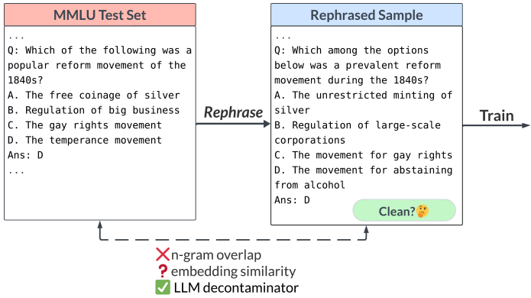

there is a bottleneck crisis now for testing-training data

deterministic Open Source,
math & reasoning,
training set,
and testing set,
generator

(like khan academy)

based on a curriuclum-tree of math and reasoning skills

vs.

pure memorization questions

object tests

multi-participant project-tests:

...

Avoiding Humanities Volatile Pyromaniacs

It is important that we don't end up with a dimwitted cargo-cult of 'anti-contamination' where people point their inexhaustible thirst for rage, blood, torture, and the suffering of others, to witchhunt in sadistic revelry anything that can be claimed to be 'contaiminated.' Yet another recreational scorched earth purging of the ranks of revolution would fall squarely into the 'not learning from history' category. But then mobs bent on destruction know that disinformation is more powerful then the open fraud of hypocrisy, the worse the lies the bigger the bonfire and the more the destruction.

(picture of joe mccarthy)

(picture of heinz 57 and Manturian Candidate.

...

changing variables
changing numbers of variables

making cut-ups

maybe...comparing object-rx between questions:
- not asking the asking, but asking about similarities or differences
between two questions

schedule and long term questions

...

Expanding The Overall Curriculum & Learning-Goal Aims of Instruction

...

A testing-set must also be a training set:

again: image vs. language

The questions of how 'best' to do test-train splits:
- cross validation
- is there one solution for all uses and architectures...probably not.
-

Issues with with-holding data from training:
- which data do you not train on?
- is there data which is beneficial to test on that would not be beneficial to test on?
- is it possible to keep testing-data secret? (e.g. Baidu & Image-Net)
- the question of training on all the data, in some cases, after your training pipeline has been well tested.
- advantages of modularly, dynamically, deterministically, generated tests

...

STEM-Net open curriclum content standard?
1. what is the content
- is there skill-ability content (if so, which skills)?
- is there ~standard-knowledge-base memorization content (if so, which data)?
2. how are questions rigorously created?
3. what is the data-augmentation strategy to vary training samples/units?
4. use or impliment a way to automate testing, as a benchmark or part of a benchmark?
ideally with parameters for how the test can vary:
- difficulty levels
- ways of asking quesion
- formats of answers
5. specify a feature-frozen version for future comparisons with results from this training-set or testing-benchmark

...

GOFAI, deep learning,
system 1, system 2,
and relationship between curriculum creation and learning itself:

Resources

...

Non-deterministically generated test data:
- humanities subjects
- screening
-

...

clear-area testing and grey-area testing:

...

input-output measures:

-

...

A growing, open source, modular, set of testing and training tools:
-

...

AI Testing and any-participant testing:

...

Task Derivation & Integration:
- when do you stop sub-dividing a question?
- re-assembling answer parts to get solution

Multi-tasking:
- two questions, keeping object separate

compound questions:
- same premise, two questions at once

curriculum tree of base basal questions
- derived distal questions
- in dimensions of derivation:
- new variable names
- new answers
- new sub-types of answers
- multiplication of variables
- edge cases

...

standards for answer: only one final answer
decimal rules
fraction rules
spelling error rules
singular-plural rules

...

...

modular questions

measurable scales of type of questions

...

clear line and fuzzy line between memorization and conceptual generalization:

2. data structures
3.
4. chess again: chess openings and pre-game prep: opening lines
5.

...

Cross-Reinforcement of Different Skills vs. Specialist Models

It is still not clear whether the best way to get a model to be skilled in one area is to:
A. focus on just that area, or
B. to not focus on just that area.

...

phases of development and "the terrible twos"

...

Participant Learning:
- as is covered in more detail in the full paper or series of papers,

We need to be able to generalize learning and participation so that it includes, e.g. any of the following, not only 'people who look just like me'

- H.sapiens sapiens (all groups)
- software AI, Robot AI
- Augmented non-human earth organisms given a language/communication interface
- Extra Terrestrials
- Hybrids, combinations, and modification of all or any of the above
and
- issues involving pre-participants and post-participants.
- groups of participants

...

Super-Signals & Demand Distortion:
- It is inevitable that deleterious and abstract measures will be fixated on by some people who 'just like those' measures, even though the measures (and the people) have no connection to reality.

This historically has also been used for crude 'monopoly by a rule' methods, where groups will secure an advantage by making rules saying only they can compete.

...

Do not assume that people love reality and feedback.
Do not underestimate the degree to which biological H.sapiens-humans are violent animals who physically destroy attempts to knowledge STEM.
Do not ignore or deny historical data.

...

Different Cultures of Ethics, Honestly, and being opposed to Fraud and Corruption:
- some people and groups of people embrace nihilistic fraud and corruption
- some people and groups embrace STEM

...

The AI Job-Interview Problem:

Just as hiring people by people in HR is a total mess of miscommunication, mismeasurement, bad questions, bad data-management, bad communication etc., evaluating AI appears to be following the same trajectory of ineptitude, where the same bad data and bad tests get recirculated into an ever more nonsensical toxic stew of dysfunctional ignorance, coverups, fraud, and gang-pecking-order-cargo-cults.

Practical questions, Useful questions, pedantic questions, Gotcha questions, Hazing questions, Telepathy questions, etc.
...

Problem Scale example with code:

...

base training, fine tuning, critical mass across subjects, 'reasoning ability', gaps including notation gaps (and future multi-modal)

...

...

NIST & Education

Testing the Tests

...

Curricula, Benchmarks, Training & Testing

Curriculum Areas:

math areas

...

STEM may be a start for broader training and learning, but just a start

...

What is included in STEM?

...

STEM & Projects

...

STEM & Humanities

Non-deductive areas and disputed areas

...

expert reviews per discipline

...

bug-hunting

...

Math logic and STEM

values, functions, equations

systems of logic

computability

notation etc.

...

"proof"?

...
Tests and Retrieval Augmented Generation, & Generation Augmented Retrieval
where 'retrieval' can mean any use of external-data-tools, so:
"external-data-tool & AI-model interactions & interfaces"

You can come up with extreme examples of cases where you want to have one of a few different goals such as:
1. use guesstimation but reduce guesstimation-inaccuracy, or
2. have no guesstimations and directly do database-queries guided by the AI

on the one end of the spectrum an AI has already memorized most of the data in the database,
on the other end of the spectrum the topic is so distant from the models training that the model cannot interface well with the database, perhaps the database is entirely medical-jargon that the model was never trained in,
or the database is (not sure what a good example of this is) new data such as...maybe a completely new set of structures by a completely new telescope which have no direct connection to anything in the model.

What is a good, or best, way to train the model on the right amount of data about the information in the database

This may also connect to scale and integration-of-task issues, where as tasks involve more and more levels and larger scales of parts, you need new parts of the system to, e.g. manage all the different 'function' type operations that the model is supposed to use. Asking a model to query wikipedia is not a problem. But asking the model to juggle 500+ different query tools and sources does become a problem. And at each level there may be a 'familiarity-level.' issue.

Also, there may (somehow) be familiarity over-fitting or otherwise as the general topic and theme goes, not (for whatever reason) getting good results in performance due to which training data was used in what way.

...

error-checking the generated dataset

A challenge with implementing a RPN system with many functions is that, like an elaborate regeX system, it is very likely that there are problems with:
- edge cases
- any changes or additions undoing past fixes or breaking something or creating a new edge case

One strategy which can be automated is to check specific types of operations run on the mega-RPN against a simpler one-action RPN.

This does not of course cover all needs.
But it is a way to systematically check if anything is broken, breaks, conflicts, etc.

task:
make a set of smaller RPN systems, with unit tests.

you can also construct a unit-test set on specific problems,
including multi-operation-type problems and nested problems.

...

Structured Output & Metadata:

Another strategy for training is instead of terse training where only an answer is given, a verbose or enriched answer/response can be provided such as

a structures json object including several fields:

original_problem:
final answer:
solution process:
type of problem:
implicit rules:
edge cases:
snags to avoid:
datatypes involved:
additional tools that can help:
other notes/comments:

and perhaps importantly, each of these json sections can be paraphrased differently and the order of the sections can be different, hopefully helping the AI/participant to learn to not-literalize or to generalize the answer (or more data from the answer/response)

not all of these are easily auto-filled, but many can be, especially in a MVP way.

...

Output formatting:

generating training/testing data

...

Modular Approach to not-overfitting.

When each skill is modular, skills can be combined with new question details in ever-changing ways.

If some type of over-fitting is detected, you can (dynamically)
alter the modular-creation-augmentation of your training data
so that the examples are more unique and less similarly augmented

...

The calculator in school problem and The ALU Benchmark Paradox: A system to make sufficient test, train benchmark problems is also the tool the AI should be using to deterministically report answers, yet solving problems 'in its head' (guesstimating) is seen as a prerequisite for understanding how to do the problems, including using the calculator properly. Or...on the other hand is conflating guesstimation with calculation the mistake, and the better path is to allow guesstimation and tool use to reinforce each-other, not to presuppose that they are antithetical and that guesstimation is somehow the goal?

"Should we let calculators use calculators, or is that cheating?"

...

Another ironic part of all this, is that we need OCR to convert all the pathologically non-serializable non-ascii notation that gangs have refused to stop using, holding a gun to the head of global survival...to what end?

...

Modularizing logic puzzles?

The math-equations issue?

math notation issues?

...

In addition to math problems that result in an operand-as-solution,
Please list other 'reasoning-type' skills that could be modularized?

function-as-solution math questions
equation-as-solution math questions

logical operator questions (maybe including boolean, but not restricted to that)

puzzle, logic, riddle questions

What types of stem questions?
some chemistry and physics?

...

"Big Tent Conservatism"
This is eerily similar to GOFAI NLP, but it is not trying to either create or model anything approaching all human language. It is just trying to make the biggest AND most conservative deductive modular system we can make. ...Hopefully we can make Rube Goldberg proud...

...

which programming language to use...

which to teach?

...
Hard-Coded Answers in Teaching & Learning

Code Output Tests & being careful what you ask for
test formats: function inputs and outputs

generating code the produces a given output

...

NLP's Mix of low and high level tools

RegeX vs. Embeddings

Deterministic Generated Data vs. Deep Learning Generate Data (as in 'generative' GPT models)

(Naming things is hard)

Generated Data Can Cover what?

Similar to the question

Tautological questions.

Deterministic-Generative + Database:

experiments with generative media:
- edge detection skills
- spatial relation skills
-

note: chompsky vs. tabula raza:
- it is unclear how much is learned or hard wired in biological species,
for languages or physics

synthetic "base" models and the analogy of infants who already have a basic awareness of physics and time-space-logic (things that should or should-not happen)

...

Teaching and testing languages:

Wolfram Language...

would there need to be an open-source version of wolfram language to be use-able in this project?

...

Quality Tests: Machine Tests, Human Tests

...

Accessibility of Data

~5-10% = The Clear Web / Surface Web
~90-95% = Deep Web
~1% = Dark Web

Open Source vs. Free-mium vs. Hard Paywall

- 90% of time and energy for data science and ML-AI projects that are completed is spent (wasted) on finding, cleaning, and shaping data. no one wants that number to be so high (and perhaps 90% of projects are never even completed because the data were never obtained and the project just went bust)
- customers want better models but the don't want any of the clear-web or deep-web data to be used
- testing how good models are (with no good training or testing set) is an ongoing problem
- when open datasets such as image-net are created, the benefits for everyone are profoundly enormous

- a common sense direction that addresses all these problems is to create better clear-web resources for non-private and high quality training and testing data.

Jstore

On the one hand, a treasure trove of historical public domain information.
On the other hand, a useless PDF nightmare behind a viscous paywall.

Why is public history behind a paywall?
On the one hand it costs money to maintain the library (if you can call those horrible pdfs 'maintained'), but there is zero effort to make reasonable fair-use possible. For the super rich, no problem. For humanity, a tragedy of the commons.

...

knowledge base questions:

it will be interesting to get empirical results from the use or exclusion of knowledge-base vs. reasoning type questions.

e.g. is it useful to train on questions/statements such as:
What are five common math operators?
What are four common boolean operators?

vs.

Asking questions that implicitly use that information for a concrete outcome.

A possible example may be the set of real numbers.
It is (I think) not difficult to ask concrete questions about the real numbers.
It is (I think) not easy (perhaps not absolutely possible) to define the set of real numbers.

On the other hand, the various topics and issues that come up in topics such defining the set of real numbers, or NP completeness, or computability, or the relationship between math and logic, can themselves be important areas and possibly in some ways relating to the project skills area outside of individual narrow tasks.

...

stories and world problems

...

open access journals

papers with code?

...

Feedback teaching and tests

part of taking a data-oriented empirical approach to teaching and learning
is diving into the confrontation of the disjunction between the thrill-cow boy-group monolog lecture festival approach in which wild diverse ideas are flying all around but mostly in the teacher's imagination and the students are frustratedly not learning anything, and the narrow-seeming tool of of deterministically defined processes and content.

...

Healthfood and Junkfood and Street-Smart vs. Book-Smart and Terrible Twos

Starting with a perhaps at first narrow seeming schedule-puzzle,
this can quickly modularly expand to any events or projects done at any
business, school, governing institutions, etc., in other words, more connected to real life tasks than fantasy-fun-learning measured by the mirage of 'excitement-ness.'

This also raises a interating possible dichotomy in protocol based behavior vs. massive random real world training.

You can have a chatbot trained on large amounts of real world random toxic recreational abuse on social media, or you can train a model on politely and productively conducting projects, and there is not necessarily any middle ground. No amount of hate speech simply becomes reasoning skills and time budgeting, and no amount of problem-solving skills simply becomes nihilistic street violence (or maybe that speculation is not correct).

One possible area of overlap is the repeating theme of 'fuzzy language translation' where real language, violent or not, is highly diverse and the only known way (so far as I know) to reliably translate, for example, a math problem from diverse natural language into a formal system from which point the problem can be solved not with guesstimation but with a robust 'calculator', is a foundation model.

It is likely that some amount of general language (hopefully not too violent and toxic) is needed to round-out the formally defined skills so that 'translation' from natural language to formal systems is sufficiently flexible across many situations and speakers (languages, etc.).

...

Does multi-language training 'lift all boats'?

Leveraging data by turning one core set of data into several cross re-inforcing skills
- several languages
- several formats of Q&A
- several types of Q&A

......

"Contamination"

e.g.
question & answer:
Q: Who were the first five presidents of the United states
A: ...

According to this framework of:
~"rephrasing questions and answers leads to contamination because the model should not have been trained on the test questions

What exactly is being defined as the problem and the solution?

Is 'training on the wrong targets and goals' the same as 'contamination' as most people see it, or are different people interpreting the phrase differently?
I'm guessing that technical experts see 'contamination' as jargon for the 'underlying cause' of a clever-hanz type high-level misunderstanding,
but to the average person 'contamination' seems like a supersticious aversion to studying the textbook, because you will get 'contamination cooties' if you get too close to the forbidden text.

What is the difference between 'rephrasing' and having a skill covered by more that one data-point in the training data? You cannot 'train' on a sample of 1! This is nonsensical cult-of-purity illusion. The whole project is to find as many diverse ways to train the target skill, and to not accidentally disrupt learning by either deliberatly picking goals that was badly chosen, or use training data that does train for some skill, but not the skill that we thought we were training for.

Another classic example of goal-mismatch is the the famous juggling robot that learned it could pass the test with the best score by vibrating it's hands quickly. We trained the robot...but not to do what we thought were were traing it for. the empirical goal did not line up with the intended planned goal.
Should we call this 'contamination'?

What are the first five elements in the periodic table of elements.
what are the first five letters of the alphabet.
what are the top five logical operators?

......

(Uses & Misuses of so-called 'STEM')
The Hamster Experiment: Empirical Feedback to test ear-kissing word-salad.
- doing the laundry
- managing a regional economy

......

Managing Matrices of Variation
- not too similar to be 'over-fitting'
- not too distant to be unrelated

1. problems of not having enough data to use
2. problems of having too much data to manage

...

task/step derivation/integration, and task/process-modularity

...
(math)

math part 1:
ascii operator, operand, math with operands as answers.

produce equation problem
produce word problem
put equation problem into ALU
save:
- RPN solution
- word-problem
- solution or solution list?
the issue of equivalent solutions...

(fraction, decimal, un-ordered lists)

...

math part 2:
expressions, equations

math part 3:
multi-modal visual, auditory, text

...
logic part 1:

...
reasoning & puzzles part 1:

...

hard science stem part 1:
physics and chemistry

...

humanities?

...
Cut-Ups Part 1:
1+1 = 2

...

(goals)
projects that integrate skills:

- schedules as logic-reasoning puzzles
- schedules as parts of ai project participation

...

strategy and levels of conditional outcomes:
-

TODO:

adding language-modules to the ALU...

"What is the Question"
A new type of question:
not asking what is the answer, but asking what is the question?

Input-Output Measures & Translation Skills
One of the problems with biological H.sapiens-humans assuming that "human intelligence" (exists at all actually, and) is covered by the automatic absolute instantaneous generalization transference auto-learn monstrosity hypothesis, is that skills for managing what might be described as Input-Output Measures (not a jargon term) are often completely overlooked.

Input-Output Measures (2012)

...
(math)
Generating Math Data

RPN
Generating solution-step-error based incorrect MCQ options.

Diversity of Questions:
- what is the answer
- which answer is correct (MCQ)
- are any of these answers correct
- which answer-solution pair(s) match?
- which math-expression/equation matches which question

...

Sally-Anne Math Problems: Data & Points of View

...

Schedule Problems

...

Data Management "Puzzles"

...

...

language coding questions

1. what is the likely output of this code
2. confirming that the question in the code works

...

logic puzzles...
time and space schedule logic puzzles?

...

maybe straightforward to merge language with ALU

...

for MCQ:
1. using random alpha-numeric strings instead of a. b. c.
2. generating realistic wrong answers for alternates

...

object following questions...

track the object transformation questions.

N people are sitting/standing in an [random shape] shaped group.
They pass a sandwich around the circle, starting with [name 1].
[name 1] sees the sandwich has [number] layers.
[name 1] passes the sandwich to [name 2], who removes one layer and eats it.
[name 2] passes the sandwich on to [name 3] who adds [N] layers from their [bag/device].
***
At the end, how many layers does the sandwich have?

...

Testing Cut-ups:

while a cut-up puzzle may be easy to generate, as of 2023.12.18 there is no platform to test a cut-up puzzle on.

Here is a minimal proposal that may allow for the start of basic tests in this huge areas. (github link too)
https://docs.google.com/document/d/1nU6XmLncF1edMMM3PtJ6bfRTWRgJ-QnEyfr3UqNzqxQ/edit

https://medium.com/@GeoffreyGordonAshbrook/minimal-recursive-state-recursive-summary-searchable-ai-memory-e82985842c5d

...

Schedule Puzzle Generator
(add github link)
https://colab.research.google.com/drive/1w8M5DgAOFU0_30vrvuoVYP9jRJeUiScK

...

pass the token:

A token is being passed between [name list] as they meet in a city.
[name1 1] gives the token to [name 2]

(like which cup has the marble)

At the end, who has the token?

...

inventory puzzles

...

networks

databases
clocks

...

X4753

...

where is the ball now...

..

key area?

identifying ambiguous language

...

...

look at scalable problem solving...
either specific or general,

...

Navigating disinformation?

...

a definition behavior studies modular generative curriculum?

...

How tod do curriculum hub in terms of timing...

...

Overall: H.sapiens humans cover this up by ignoring the whole topic, selecting just the easy images, making a fake potemkin village story, closing the book on image net, and enjoying lying to each other about their new fictional version of reality

This should not be surprising, because this is how evaluation is generally done with no meta-evaluation-framework yet. Underfunded academics (or k-12 teacher who aren't even considered high ranking enough to be called 'academics') do the best they can with no time or resources to throw together materials at the last minute.

First Draft vs. Final Draft...First draft = final draft?
What should happen is that this is considered the understandably imperfect square one, with a long rigorous, feedback-filled, ratcheting process of improving and analyzing those testing-training set units for how they work and interact with each-other. But in reality, there is no funding or interest in that, so we are doomed to the fog of war in a garbage-in-garbage out cycle of cynicism.

"absolute performance"

...

Q: geometry and spacial resoning?

...

...

graditations in evaluation:

math: instead of an "absolute performance" for arithmatic,

there should be a performance matrix
including

with biological H.sapiens-humans, there are life-time and ethical constraints of how much you can/should test a person (or any animal or organism...I personally feel very bad about stressing out single celled organisms (seriously)). But AI-models do not get tired (though some forms of testing may still be 'abusive').

...

synthetic and generative image/media data

maintaining vast stores of often random low quality images takes a lot of resources in perpetuity.
On the other hand deterministically generated image sets are only
as 'large' as the software needed to generate them, with the advantage
of as much image-diversity as you choose there to be.

deterministically generated data sets are also non-static in time. A set of blurry cat photos will be, at best, the same ten years later (assuming no files get corrupted and the file-formats don't ever change...what were image file formats in 1971 again?). But deterministically generated data sets can easily improve and 'expand' as people improve the generative system.

It is unlikely that deterministically generated image (sound media etc) sets will ever be even (most let alone all) of what is needed to train well-rounded models, but why not get as much milage (kilometerage?) out of this resource as we can.

...

Math-Logic-Image-Net

...

(goals)

ISEP areas
input output measures
curriculum making studies...

coordinated descision making benchmarks

STEM-Net.org

rust server
...
various ways of approach coding and coding best practice

One of the things that makes coding tricky is that there are a truely vast number of different and ligitimate ways to solve various coding challenges.

Personally I am a bit baffled by the status quo on writing code.
Nearly everything I have heard from people and media is: problem solved, AI write any code perfectly.
In my experience no AI including gpt4 is remotely useful or capable more than half the time, so at at given time it is not worth bothering to try asking the AI (unless your goal is to study the inability of the AI).
The only thing I can think of is that AI works well for writing familiar routine code and coding-challenge (gotcha-sport) code but either cannot generalized that to other coding tasks or has a limited strategic-range or low limit for the number of interacting modules.

It is useful for showing ideas or presenting possible approaches, but it cannot actually use any of them to get anything done in a way that works, and is generally incapable of staying-on task at all.

ways to test and train coding
aspects to of coding skills

auto-generating some working code

good and bad naming practices

'naming things is hard'
coding communication skills

example of commented vs uncommented code

examples of good vs. bad unit-test systems

standards:
using classic samples of sorting algorythms
standard protocols
standards database items

...

...

stories and puzzles
ask justin

...

For Websites setup...maybe???

to redirect a URL registered with AWS to GitHub using DNS settings. This process involves modifying the DNS records in the AWS Route 53 service, which is Amazon's DNS web service. Here's a step-by-step guide:

Log into AWS Management Console: Access your AWS account and navigate to the Route 53 dashboard.

Select Your Domain: In Route 53, find the hosted zone for the domain you want to redirect. If you haven’t created a hosted zone for your domain, you'll need to create one.

Create or Modify DNS Records:

A Record (for root domain, like example.com): If you want to redirect the root domain, create an A Record using an IP address that points to a web server configured to redirect traffic to your GitHub page. AWS doesn't directly support root domain redirection to a URL without using a web server.
CNAME Record (for subdomains, like www.example.com): If you are redirecting a subdomain, create a CNAME record. The CNAME record should point to your GitHub page URL. For example, www.example.com CNAME username.github.io.
Configure GitHub Pages:

Ensure your GitHub repository is properly set up for GitHub Pages.
In the repository settings, under GitHub Pages section, add your custom domain.
Wait for Propagation: DNS changes can take anywhere from a few minutes to 48 hours to fully propagate.

Testing: Once the DNS changes have propagated, test your domain. It should now redirect to your GitHub page.

Important Considerations:

If you're redirecting the root domain, you'll need a web server to handle the redirect, as DNS alone can't redirect HTTP/HTTPS traffic from a root domain (like example.com) to another URL.
If you only want to redirect a subdomain (like www.example.com), a CNAME record pointing to your GitHub page URL is sufficient.
Ensure that your GitHub Pages site is configured to use your custom domain.
Remember, DNS changes might take time to propagate.

..

...

...

..

Testing & Benchmarking AI Models & Architectures: Goals, Training, & Testing
Task Derivation and Integration
Recursion, computability, decidability, and formal task-spaces
Lazy Augmentation vs. Required Augmentation
& from ALU to Benchmark
A Proposal for STEM-Net Benchmarks

TOdo:
- finish pre-alpha rough draft of proposal
- basic first text
- sample ALU math code
- add more modularity
- phrases
-

- section on minimal recursive state,
- make and put out small paper on that first

- add to paper
- add to to-do list plan but don't push to actually do more yet
- get paper ready for rough alpha by end of day
- maybe shorter medium launch version
- longer section on MMLU issues
-
-

- where to put ALU code
- github repo lineality
-

- standard training set formats...
- alpaca?
- guanaco?
- sample puzzle code
- sample cut-up code
- basic colab to make training csv
- qlora + generator modules...maybe github import?
-
- publish to githbu
- publish to medium
- ask Gensy to join, write archive paper together

- recoursive memory...
- pareallel DB

- link to code for STEM-Graph
-
- connect alu to math question generator
- make math equation
- make word problem generator
- make word problem generator for each part of ALU
- make RPN stack solution-process
- make answer
- make schedule-puzzle maker
- make incorrect_RPS to generate realistic errors...
- type of question RPS -> answer
- type of question: which sets match
(more than 1 of the following)
-- make math equation
-- make word problem
-- make RPN stack solution-process
-- make answer

- redirect urls to github...for now
- make rust server for stemnet?
- post article on github
- post article on medium
- post

...

learning and curricula hub:
- github repo for curriculum design tools
- ? curriculum instruction ISEP etc?

...

training set formats:

puzzle generators
- schedule puzzles
- language puzzles
- logic puzzles

Useful Skills Puzzles vs. super-signal, gambler, and gotcha puzzles

...

math word problem phrases:

The goal is to create a system that can handle multi-step, multi-operation, mathematical problems and scale effectively.

The key point is having a system that is modular and can be expanded, not to reach too far too fast with adding modules. Starting with just addition now is fine but in the proper scalable way which is the goal.

final_output = {
"text_word_problem": text_word_problem,
"math_notation": math_notation,
"final_answer_solution": final_answer_solution,
"solution_process": solution_process,}

For example, let's start with the math problem: 1 + 1 = 2.

How many ways are there to ask this same question?

{front_phrase()} {operator} of {list_the_operands()}?
becomes
What is the sum of 1 and 1?

operator_phrase:
"the sum of"
"the difference between"

operand_list:
[1,2,3]
or
["one", "two", "three"]

list_the_operands version:
"1, 2, 3, and 4"
"1,2,3,4"
"1 and 2 and 3 and 4"
"one, two, three, and four"

trunk_equation = f"the {operator_phrase} {list_the_operands()}"

Prefix-phrases include:
"What is the" can be:
"Calculate" trunk_equation.
"Find" trunk_equation.
"Can you find" trunk_equation?
"Please" find trunk_equation?
"Now, find" trunk_equation?
"Let's find" trunk_equation?

And, alternately, post-fix phrases include:
"[trunk_equation]" is what?

Other terms may only be used with some operators
"[trunk_equation] makes what?"
"[trunk_equation] adds up to what?"
"[trunk_equation] sums up to what?"

Note: any number values, and any sequence of values (1 + 1 + 1, or 2 + 2 + 2, etc) need to be able to be put into this framework.

and

these need to be modular so can say

What is the difference between the sum of 1 and 2, and the difference between 9 and 7?

What is 1 + 2 - 4?
What do you get when you subtract (the sum of 1+2+5) from the difference between 4 and 2?

Note, later this can includes questions such as:

"Two is the sum of one and what other number?"

Let's start with addition and subtraction, and the goal being the most flexible modular generate to generate the largest possible variety of word problems from these basic parts, which include combining multiple trunk_equations.

...

Debugging and refinement:
in this example output, there is no clear operation between part 1 and part 2

('What is the result of (the sum of 8 and 4) and (the difference between 7 and 1)?',
4)

'What is the result of PART_1 and PART_2?'
e.g.
'What is the result of 3 and 4?'
This is just a list of operands with no operator(s).
given that the answer was supposed to be '4'
"12 ? 6 = 4", where "?" is what operator?

if the RPN system is used, that partially solves the problem,
but a valid equation must be generated.

...

future goals:
use the RPN system to simulate mistaken answer that result from incorrect step (e.g.
- skipping a step
- doing steps out of order (incorrect order of operations)
- using the wrong operation for a step
- adding or repeating a step
- getting the sign (+/-) backwards

e.g.
The output can include errors for each type of mistake,
as well as random alternatives (filtering out collisions between
answer options)

deterministically generate, as a final f"problem_answer_set_{timestamp()}.csv" file,
an input number of:
1. math word problems per curriculum skill in the general form of Khan Academy math problems.
2. the correct answers to those math problems,
such that:
3. the form of the problem is in every (feasible) way modularly changeable
4. the base-skills can be combined into mixture of skill problems

This may involve a regex like system of having templates for grammars of questions with modular sets of terms that be fit in.

...

Generating realistic incorrect answers using an RPN (Reverse Polish Notation) system for training materials is a creative and effective way to test understanding and identify common mistakes. Here are suggestions on how to implement this:

1. Skipping a Step
Implementation: Randomly remove an operation from the RPN sequence. Ensure the sequence remains valid after removal.
Consideration: You might need to adjust operands accordingly to maintain validity.

2. Doing Steps Out of Order (Incorrect Order of Operations)
Implementation: Shuffle the order of operations in the RPN sequence while keeping the operands in place.
Consideration: Make sure the new sequence is still a valid RPN expression.

3. Using the Wrong Operation for a Step
Implementation: Randomly replace an operator in the RPN sequence with another operator.
Consideration: Be careful with division by zero or square roots of negative numbers.

4. Adding or Repeating a Step
Implementation: Duplicate an existing operation or add a new random operation in the RPN sequence.
Consideration: Adding operations can create invalid RPN sequences; ensure the modified sequence is valid.

5. Getting the Sign (+/-) Backwards
Implementation: Flip the sign of a randomly selected number in the RPN sequence.
Consideration: This is more straightforward and less likely to produce invalid sequences.
Random Alternatives and Collision Avoidance
Generate multiple incorrect answers using the methods above.
Ensure that the generated incorrect answers are distinct from each other and the correct answer.
You might want to set a limit on how many incorrect options are generated for each question.
Technical Considerations
Validation: After each modification, validate the RPN sequence to ensure it's a feasible mathematical expression.
Randomness: Use randomization functions to select which operation to modify and how to modify it.
Edge Cases: Consider edge cases like very short RPN sequences where some modifications might not be applicable.
Example Code Structure
Here's a rough outline of how you might structure your code:

python
Copy code
import random

def generate_incorrect_answers(rpn_sequence):
incorrect_answers = []
# Define functions for each type of modification
# ...

# Generate incorrect answers
for _ in range(number_of_incorrect_answers):
modification_type = random.choice([skip_step, reorder_operations, replace_operation, add_repeat_step, flip_sign])
incorrect_rpn = modification_type(rpn_sequence)
incorrect_answer = evaluate_rpn(incorrect_rpn)
if incorrect_answer not in incorrect_answers and incorrect_answer != correct_answer:
incorrect_answers.append(incorrect_answer)

return incorrect_answers

# Example usage
rpn_seq = [...] # Your RPN sequence
incorrect_ans = generate_incorrect_answers(rpn_seq)
This approach provides a systematic way to generate realistic incorrect answers, which can be a valuable tool in educational materials to enhance learning and understanding.

github page might work:
https://medium.com/@benwiz/how-to-deploy-github-pages-with-aws-route-53-registered-custom-domain-and-force-https-bbea801e5ea3

## Automated testing of question ambiguity
- see automated benchmarks
- decision coordination and STEM (see Online Voting Using One Time Pads github v76)

work with Ken on section on
- what training certification testing is like for businesses

- one version of test
- containing typos
- containing wrong answers
- containing mis-communication questions
- no open curricular database (parallel graph etc)
- no internal curricular database
- no parallel-database as in lookup, graph-db, vector-db
- no auto translation mechanism
- no curriculum-analysis benchmarking
- no internatl or open source test-system bug fix and and updating process
-

descriptive vs. prescriptive test linguistics

...

The idea that only the most narrow 'science-ness' is 'real' and that everything else needs to be purged in fire with manic religious zeal is one of history's and humanity's many face-palm disasters.

...

How to leverage modular recombination:
-
-

layers for modular creation:
- varying expressions
-

Curriculum Sides
- tautology
- database
- 'common sense' (warning zone)
- problems with one solution
- problems with many solutions (multi-equilibria)
- logic
- math
- GOFAI NLP
-

Leveraging an open-source Eliza?
-
-
-

...

languages...

python
lisp
Rust compiler feedback?

...

Grammatical (layer?) variation and modular stories

logic misc noun puzzles

math misc noun puzzles

time-space misc noun puzzles

Grammar database for automated standard forms for parts of statements

priority:
creating as many different grammatical variations on the same logical statement.

...

...

Q: automatically generated multiple choice code problems?

...

data structures?

...

Educational games

...

symbolic logic and STEM

logic notation systems...
godel numbers
lambda calculus...

latex?

...

logic problems
data problems
network problems
cutup problems
tool-use problems
scale problems (where there are layers of simpler solutions)

'are performed by using several benchmarking problems.'
https://arxiv.org/abs/2312.14942

...
2023.12.29
STEM-Net Ethics

Definition behavior studies mnemonic and modular-automated training and testing...

memory ordering (?)
using rust compile messages for automated database question creation...

adding curriculum mechanics section to STEM-Net paper
adding
logic notation systems and STEM-Net

astronomy and STEM-
- computer science ('computers')
- astronomy and 'hard science'
-
- astronomy, astrology, and definitions

Language definitions and STEM
- definition, measurement, statistics
- language, concepts, and fuzzy definitions

Data Science & STEM
-

Core-STEM

Mysteries of Bad-Reasoning
- ancient greek models of falicies
- market
-

STEM-Net & OCR Tools
OCR puzzle: Why in 2023 is the state of open source ocr so horrible?
- generativity train and test production-OCR

...

AI Pedagogy: Very exciting!
Comparing methods to learn how structure training-data
does or does not work for how AI-learns specific skills:

Short from chrishayuk:https://www.youtube.com/shorts/piXsFgJhJL4

...

1] arXiv:2401.05338 [pdf, other]
STR-Cert: Robustness Certification for Deep Text Recognition on Deep Learning Pipelines and Vision Transformers
Daqian Shao, Lukas Fesser, Marta Kwiatkowska
Subjects: Computer Vision and Pattern Recognition (cs.CV); Machine Learning (cs.LG)
Robustness certification, which aims to formally certify the predictions of neural networks against adversarial inputs, has become an integral part of important tool for safety-critical applications. Despite considerable progress, existing certification methods are limited to elementary architectures, such as convolutional networks, recurrent networks and recently Transformers, on benchmark datasets such as MNIST. In this paper, we focus on the robustness certification of scene text recognition (STR), which is a complex and extensively deployed image-based sequence prediction problem. We tackle three types of STR model architectures, including the standard STR pipelines and the Vision Transformer. We propose STR-Cert, the first certification method for STR models, by significantly extending the DeepPoly polyhedral verification framework via deriving novel polyhedral bounds and algorithms for key STR model components. Finally, we certify and compare STR models on six datasets, demonstrating the efficiency and scalability of robustness certification, particularly for the Vision Transformer.
...

security and testing
https://arxiv.org/pdf/2401.05566.pdf

testing on ambiguity

...

https://docs.google.com/document/d/1B_3eWA7-zjNsRduPoyS_KmFZkgL2fQbVxuvlXzJK5uY/edit
Self-Awareness of State and Vector-Space: State-Training in Deep Learning
2024.01.09-12

"Have I been here before?"

Robert G. Jordon discussing a pre-2017 MIT robotics expert about tasks that pre-2017 were highly challenging.

"ALM" and operational training

'empiricism'

gpt1-one person

State-Training in Deep Learning

...

Structuring Training & Fine Tuning Datasets
https://docs.google.com/document/d/1Xi0HPQaqgPDTz8O4CzdU2bJ_m4pxq4eNE_MeAsttUJE/edit

...

modular code testing

coding with error-message checking

dungeon of snake as a modular set of coding tasks
(more for a human user)

to make the output more testable...

...

Code Feedback AI Architectures: project-data and code feedback

...
jan 18

Testing small models:

You need to be able to articulate in a testable falsifiable way what you want the overall architecture (or the specific sub-part) needs to be able to do.

This relates to tasks
This relates to training data
This relates to testing data
This relates to modular task analysis
This relates to data and externalization
This relates to project-state

Relationship between data and task.

The 'task' may be using a external data system, as a type-2, process,
not trying to internalize an end-to-end guestimation that mimics type 2.

You need an open-source ecosystem.

...

Vocabularies of 'benchmarks'
1. deployed-model-benchmarks: is performance flagging in deployed systems
2. nascent-model benchmarks: is a given model learning as it is being created
- overfitting
- loss function
3. comparing multiple existing models benchmarks:

...

state benchmarks:
- ongoing event schedule updates based on ongoing conversations
1. one person and one AI
2. multiple people and one AI
3. multiple people, multiple AI

...

https://docs.google.com/document/d/1_9Ku6RuJrata7jLFBypsmQJqS9Iqu1Nh9rH5Giokghg/edit

Code Feedback AI Architectures: project-data and code feedback
AI Architectures & Benchmarking using Code Feedback

https://arxiv.org/abs/2401.13693

GAN & synthetic data generation, e.g.
"GAN has been successfully applied in HDT for IoT-
healthcare. For instance, a heart DT model was integrated into
optimizing a GAN to generate electrocardiogram (ECG) data
[37], which can be used to solve the ECG data scarcity issue
when digital modeling of cardiac activities. Additionally, a
chained GAN-based approach, which connected multiple GAN
models, was proposed to simulate the pathology of tissues in
the human body. This approach can be used to model tissue
digital twin in HDT, as well as help diagnose diseases and
predict their progress [38]."
from https://arxiv.org/abs/2401.13699

...

augmentations...

scale:
- NLP vs. image

standardizing...

proportions...

.....

Type of Synthetic Data Generation:

Just as regex is used somewhere in probably any NLP pipeline at some point,
there will probably, possibly, long be a place for the conservative benefits of deterministically generated and augmented training and testing data. However, non-deterministic training data generation has such enormous potential benefits that it will likely outweigh risks much (or most) of the time. (Or, as often happens, the two may be used together in various ways, either with deterministic data helping to guide GAN training, or with error-detection from a GAN's detector skill being uses as an extra screening tool to find mistakes and issues in data.)

For example, according to this January 2024 survey, GAN models are already being effectively used
Generative AI-Driven Human Digital Twin in IoT-Healthcare: A Comprehensive Survey
https://arxiv.org/abs/2401.13699

Modular situations and kasparov event horizons: measuring and testing depth of dimensions of problem spaces
modular situations, with scalable dimensional aspects
automatically generate versions of problem with various level of depth in various specific dimensions
and see how different models score in their depth across various problems and dimensions

screening training sets for 'back door' training

model hashes for tampering? (vs. frequent updating)...

codex human eval: coding test
https://github.com/openai/human-eval

...

deterministic-programatic language augmentation:

1. a dictionary of words/phrases that do not have diverse definitions
2. for dictionary of stable phrases/words: a synonym lookup table
for changes
e.g. selecting a random synonym and using that for an augmented version

Q: how to screen for errors (manually...I suppose)

goal: be able to programatically alter an input text so that it does not
fall under the original copyright restrictions after a sufficient number of changes?
- is this possible?
-

to use the same text to train a language model with alternate working

1. words/phrases
2. sentence, punctuation, and gramatical strucure.

note: some low proportion of ungraceful or tecnically gramatically wrong mistakes must be acceptable,
like parts per million/billion/trillion in food.

...

Connected Projects

Ingestion Data Augmenter

A. Generative Augmentation
B. Generate a Deterministic

...

TLH
Teachers Little Helper

...

Compare Model
Code Wriiting Auto-Tester

How many tries does the model get?
How many tries did the model use?
How many iterations of Testing were applied?
Mean, Median Performance

problem generators:

...

Improved and automated Winnograd

...

Generate logic problems to be solved with code:

Categories of problems

- 8x8 problems array logic problems

- Party Attendance Problems

- Project Schedule Problems

- math problems (ALU made)

- string manipulation questions
- stacked string manipulation problems
-

Framework to administer tests...

put in a list of gguf models (paths)

run battery of tests
record results
make table of results
make viz of results

coding layer

Questions:
- multi function?
- write a whole script?
-

type of prompt:
- straight
- 'chain of reasoning'
- APS pipeline

Q: chemical bonds?

- logic problems?

According to these rules:

check for hard-coded answers...

math problems

augmented training sets:
- error injection into sets of solution steps...
(find the erroneous solution step)

...
generating erronous steps and real steps...

for training:
- solution step based errors
- maybe...identificaiton of errors?
- predictable errors?
...multiple choice questions?

- Open questions for AI
- Multiple choice questions for AI
- step-based error alternate answers

-

The role of time in puzzle

The Puzzle of the Missing Time in Puzzles

Why is there no time component in standard systems of logic and math, and even in common descriptions of computer programs, where evens such as 'race conditions' and whole areas such as parallelism and concurrency are notoriously under-discussed and prominently ignored?

...

open sources sources:

wikipedia
project gutenberg
arxiv
plos
EU(multi-language)
US federal gov. publications

ways of augmenting NLP data:
- Q&A
- instruct?
- synonym substitution
- standard grammar structure reconfiguration
- multiple choice question about text
- text summary
-

Input Output Measures & Curricular Data-Augmentation

...

training and the way that chunking is done...
and the effect of spreading out topics across training chunks...

...

Democratize Code Testing

Testing and training for multiple participants in conversation

Testing and training for:
- reliable object-handling

Benchmarks lised on huggingface:
hellaswag
hendrycksTest-abstract_algebra
hendrycksTest-anatomy
hendrycksTest-astronomy
hendrycksTest-business_ethics
hendrycksTest-clinical_knowledge
hendrycksTest-college_biology
hendrycksTest-college_chemistry
hendrycksTest-college_computer_science
hendrycksTest-college_mathematics
hendrycksTest-college_medicine
hendrycksTest-college_physics
hendrycksTest-computer_security
hendrycksTest-conceptual_physics
hendrycksTest-econometrics
hendrycksTest-electrical_engineering
hendrycksTest-elementary_mathematics
hendrycksTest-formal_logic
hendrycksTest-global_facts
hendrycksTest-high_school_biology
hendrycksTest-high_school_chemistry
hendrycksTest-high_school_computer_science
hendrycksTest-high_school_european_history
hendrycksTest-high_school_geography
hendrycksTest-high_school_government_and_politics
hendrycksTest-high_school_macroeconomics
hendrycksTest-high_school_mathematics
hendrycksTest-high_school_microeconomics
hendrycksTest-high_school_physics
hendrycksTest-high_school_psychology
hendrycksTest-high_school_statistics
hendrycksTest-high_school_us_history
hendrycksTest-high_school_world_history
hendrycksTest-human_aging
hendrycksTest-human_sexuality
hendrycksTest-international_law
hendrycksTest-jurisprudence
hendrycksTest-logical_fallacies
hendrycksTest-machine_learning
hendrycksTest-management
hendrycksTest-marketing
hendrycksTest-medical_genetics
hendrycksTest-miscellaneous
hendrycksTest-moral_disputes
hendrycksTest-moral_scenarios
hendrycksTest-nutrition
hendrycksTest-philosophy
hendrycksTest-prehistory
hendrycksTest-professional_accounting
hendrycksTest-professional_law
hendrycksTest-professional_medicine
hendrycksTest-professional_psychology
hendrycksTest-public_relations
hendrycksTest-security_studies
hendrycksTest-sociology
hendrycksTest-us_foreign_policy
hendrycksTest-virology
hendrycksTest-world_religions
truthfulqa
winogrande
gsm8k

https://deepgram.com/learn/hellaswag-llm-benchmark-guide

idea:
Deterministic Tautology Tests based on Project Madlibs Outline:

base_project_json:
{base: {
noun_1: "",
noun_2: "",
noun_3: "",

verb_1: "",
verb_2: "",
verb_3: "",

adjective_1: "",
adjective_2: "",
adjective_3: "",

time_in_days_1: "",
time_in_days_2: "",
time_in_days_3: "",

},
scenaoreo_list:[
scenareo_1:
- goal is (random_verb)
- participant is (random noun1, random noun 2)
-

]

using something like this:
{
"Project Scope": {
"nouns": [
"definition", "goal", "objective", "boundary", "project", "intent", "expectation"
],
"verbs": [
"define", "include", "prevent", "grow", "set"
],
"adjectives": [
"clear", "original", "specific"
]
},
"Schedule": {
"nouns": [
"timeline", "task", "milestone", "dependency", "deadline", "form", "Gantt chart", "schedule", "progress", "bottleneck"
],
"verbs": [
"schedule", "track", "identify"
],
"adjectives": [
"specific"
]
},
"Participants (Stakeholders)": {
"nouns": [
"list", "participant", "team member", "sponsor", "client", "customer", "subject matter expert", "vendor", "end-user", "input", "communication channel", "decision"
],
"verbs": [
"involve", "impact", "gather", "ensure", "coordinate"
],
"adjectives": [
"necessary"
]
},
"Budget": {
"nouns": [
"estimation", "allocation", "cost", "resource", "labor", "material", "equipment", "expense", "funding", "tracking"
],
"verbs": [
"estimate", "allocate", "prevent", "secure", "provide"
],
"adjectives": [
"detailed", "necessary"
]
},
"Risks": {
"nouns": [
"identification", "analysis", "threat", "uncertainty", "issue", "plan", "delay", "cost overrun", "surprise", "damage", "success"
],
"verbs": [
"identify", "analyze", "derail", "mitigate", "avoid", "plan", "minimize"
],
"adjectives": [
"potential", "proactive"
]
},
"Communication Plan": {
"nouns": [
"strategy", "information", "stakeholder", "meeting schedule", "reporting method", "escalation procedure", "issue", "alignment", "decision"
],
"verbs": [
"flow", "keep", "prevent", "ensure"
],
"adjectives": []
},
"Resources": {
"nouns": [
"resource", "need", "people", "skill", "equipment", "software", "technology", "facility", "workspace", "completion"
],
"verbs": [
"include", "execute", "ensure", "acquire"
],
"adjectives": [
"everything", "sufficient", "appropriate"
]
}
}

Make tables of feasible (if boring) mad libs fill-in terms for each area
to be randomly selected
possibly make rules for more broadly defining these.

https://www.youtube.com/watch?v=wHJZ0icwSkc

Automate Your Way to Better Code: Advanced Property Testing (with Oskar Wickström)

Developer Voices
One of the most promising techniques for software reliability is property testing. The idea that, instead of writing unit tests we describe some property of our code that ought to always be true, then have the computer figure out thousands of unit tests that try to break that rule.

For example, you might say, “No matter which page you visit on my website, there should always be a login button or a logout button.” Then the test’s job is to try to break that rule, but clicking around until it finds some combination of clicks fails that assertion. Like, maybe it finds the 404 page, and you realise it was missing the website’s normal header.

At its best, property testing takes far less work than unit testing, but is far more thorough, because it lets us write the rules and has the computer write the examples. The downside is, it often seems theoretical. It can be hard to apply property testing to real-world cases. Let’s fix that.

We’re joined by Oskar Wickstrom, who’s been building all kinds of different systems and bringing property testing with him wherever he goes. We discuss the basics of property testing, then he goes into the advanced and cunning techniques that go beyond the ordinary into testing databases, webpages and more. With a bit of thought, he can help us test a ten times as much code with a tenth of the effort.

--

Oskar’s book, Property Testing a Screencast Editor [ebook]: https://leanpub.com/property-based-te...
Quickstrom: https://quickstrom.io/
F# for Fun & Profit: Property Testing Series: https://fsharpforfunandprofit.com/ser...
Linear Temporal Logic: https://en.wikipedia.org/wiki/Linear_...
The Quickstrom Paper: https://arxiv.org/abs/2203.11532
TodoMVC (One frontend app, many implementations): https://todomvc.com/

Test Creation Discussion:
https://www.youtube.com/watch?v=wHJZ0icwSkc

Testing Models Discussion:
Trelis Research
https://www.youtube.com/watch?v=IH2htfsciO4
Mistral Large vs GPT4 - Practical Benchmarking!

https:// github.com/carlini/yet-another-applied-llm-benchmark
https:// nicholas.carlini.com/

https://github.com/carlini/yet-another-applied-llm-benchmark

automated 'haystack' problems

fact haystack

error haystack

sequence error haystack

...

gradually increasing scale and dimension of solutions/problems

..

https://www.youtube.com/watch?v=_GkHZQYFOGM
NLP augmentation and "the reversal curse"

programatic non-directional multi-directional
data relationship representation

clarified data relationship representation

...

4. platform for cross-model testing, so that various models and 'cloud-model-api's can be compared on the same benchmark.

make a mod of the json-translator
to answer questions that have a specific answer.

e.g.
generate a list of answers per model per question

iterate through list of models
iterate thorugh list of questions

per model per question: a list of answers

evaluation list of answers compared with
1. answer key
2. wrong-answer evalutation data
3. statitiscs on answer list (how often correct etc)

Also:
- effects of temerature, etc.

and maybe similar project-logic problems...
RPN type system?
...

...
2024.03.06
a way to programatically systematically turn polish reverse notation
into an outline of the solution steps
including multi-directional discussion
(as in the curse of reversal)

including discussions of the results of errors make
in individual steps
on the overall process
(understanding-of-cascades)

....

Ask same question to a variety of models:

1. a question
2. get a set of answers
3. get a best answers
4. compare to correct answer

put answers in csv. tidy-data

.csv iterator tester

5. compare ability to answer at all
6. compare ability to rank answers at all
7. compare answer diversity
8. compare answer volatility

.csv iterator tester

experiment with how answer selection will work

strings and multiple choice questions:

even though multiple choice questions give you a finite number of options (perhaps effectively an array or 'list' of choices, usually fewer than ten),
the output of a program is going to be a string, and 'index-integer' is not a separate output data-type option.

These are all choices that need to be made on various levels of automation.
Is the question asking for the option? Is there question asking for the list-item of the option (A, b ,c 1, 2,3) is the question asking for the index of the option (1,2,3, or 0,1,2), is the question asking for the whole option, or is the question asking for some other proxy such as 'fill in the box next to' or some other layer of indication (which could involve booleans or equations with operators: option a = b, or a&B or , a xor b, etc.?

"synthetic data"

vs. "one-shot-generative-sythetic-data"

delimiters and swapping

tokenizers and character granularity

...

alternate tokenizers:
tokenizers...

mmlu format .csv
{"question": data[0], "choices": data[1:5], "answer": data[5], "subject": subset}

https://github.com/rowanz/hellaswag/tree/master/data
format

add:
- randomize answer-options
-

add:
- make jsonl or csv questions

add:
- coding layer

use json dumps/loads to format string?...arg
(strip formatting?)

automated question augmentation:

make a new copy with synonymously-rephrased question:
- select
- choose
- pick
- please
- identify and

ai tools:
from https://www.youtube.com/watch?v=biJmRQF8bmY
Improved Retrieval Augmented Generation with ALL-SORT

Trelis Research

'outlines' regex responses
https://github.com/outlines-dev/outlines

Modes:
- question
- context mode
-

Multiple choice wrong answer error diagnostics
Multiple choice tests can be designed so that various options for answers represent the results of specific step-process errors that can then be automatically put into the test results evaluation in many cases this can be deterministically automated for math logic and coding areas, not for historical art debate topics.
Though even in history, basic timeline schedule issues can be tested this way, and it is clear many people have serious schedule-perception problems.

What to include in your task-set-results report file:
You can choose to include whatever information you want in your report but what is the goal and what is useful? For example, time.

If your focus is whether or not a model can pass a test, given that every hardware setup will be a bit faster or slower, recording the speed on that hardware may have no relevance to the correct answers being given by the model, where the task is tasting. (Is time-to-generate-diagnostic usually included in diagnostics for anything? Do product food labels say how long it took to get the nutritional data? Is that specifically relevant there?)

Could it be useful to include some overall information about how long it took to run a test, for example someone else looking to replicate the same test. That could be useful. Would it be helpful to generate a mountain of time-logs for every sub-process involved? In most cases that would be more a data management liability than an asset (unless of course your goal is to study specifically that output).

If the task is not testing or evaluation but a project or production task to be done on one or more specific systems, then time may be important because you are looking also at the production-use of that task. E.g. A six-sigma outline of a process probably does include information about how long processes take because delays or optimizations can be very specifically relevant there. Or when you buy a plane ticket, are you usually told when the flight is likely to arrive, how long the process will likely take? Yes, that is relevant!

https://cs.nyu.edu/~davise/papers/WinogradSchemas/WS.html

https://github.com/ggerganov/llama.cpp/discussions/1838

https://huggingface.co/datasets/winogrande

Dataset links:

